**CLUSTER ANALYSIS OF OBJECTIVELY MEASURED PHYSICAL ACTIVITY IN CHRONIC OBSTRUCTIVE PULMONARY DISEASE: A MULTICENTRIC CROSS-SECTIONAL STUDY**

Rafael Mesquita1,2,*, Gabriele Spina3,*, Fabio Pitta4, David Donaire-Gonzalez5, Brenda M. Deering6, Mehul S. Patel7, Katy E. Mitchell8, Jennifer Alison9, Arnoldus J. R. van Gestel10, Stefanie Zogg11, Philippe Gagnon12, Beatriz Abascal-Bolado13,14, Barbara Vagaggini15, Judith Garcia-Aymerich5, Kylie Hill16,17, Elisabeth A. P. M. Romme18, Samantha S.C. Kon7, Paul S. Albert19, Benjamin Waschki20, Dinesh Shrikrishna7, Sally J. Singh8, Nicholas S Hopkinson7, David Miedinger11, Roberto P. Benzo14, François Maltais12, Pierluigi Paggiaro15, Christine Jenkins21, Michael I. Polkey7, Sue C. Jenkins17, William D-C. Man7, Christian F. Clarenbach10, Nidia A. Hernandes4, Daniela Savi22, David R. Hillman23, Karina C. Furlanetto4, Zoe J. McKeough24, Sally Watts24, Li W. Cindy Ng17, Diana Jarreta25, Anne Kirsten20, Dina Brooks16, Peter R. Eastwood23, Thaís Sant'Anna4, Kenneth Meijer26, Selina Dürr11, Malcolm Kohler10, Vanessa S. Probst4,27, Ruth Tal-Singer28, Esther Garcia Gil25, Jörg Leuppi11, Peter M.A. Calverley19, Frank W. J. M. Smeenk18, Julie Yates28, Richard W. Costello6, Marco Gramm20, Roger Goldstein16, Helgo Magnussen20, Emiel F.M. Wouters1,2, Richard L. ZuWallack29, Oliver Amft3,†, Henrik Watz20,†, and Martijn A. Spruit1,30,†.

*Joint first authors †Joint senior authors

1Department of Research & Education, CIRO+, center of expertise for chronic organ failure+, Horn, The Netherlands.

2Department of Respiratory Medicine, Maastricht University Medical Center+ (MUMC+), Maastricht, The Netherlands.

3ACTLab, Signal Processing Systems, TU Eindhoven, Eindhoven, The Netherlands.

4Laboratório de Pesquisa em Fisioterapia Pulmonar, Departamento de Fisioterapia, Universidade Estadual de Londrina (UEL), Londrina, Paraná, Brazil.

5Centre for Research in Environmental Epidemiology (CREAL), Barcelona, Spain.

6Department of Respiratory Medicine, Beaumont Hospital, Dublin, Ireland.

7NIHR Respiratory Biomedical Research Unit, Royal Brompton & Harefield NHS Foundation Trust and Imperial College, London, United Kingdom.

8NIHR CLAHRC-LNR Pulmonary Rehabilitation Research Group, University Hospitals, Leicester, United Kingdom.

9Physiotherapy Department, Royal Prince Alfred Hospital, Sydney, NSW, Australia.

10Pulmonary Division, University Hospital of Zurich, Zurich, Switzerland.

11Internal Medicine, University Hospital of Basel, Basel, Switzerland.

12Centre de recherche, Institut Universitaire de cardiologie et de pneumologie de Québec, 2725 Chemin Ste-Foy Québec, Université Laval, Québec G1V 4G5, Canada.

13Division of Pulmonary. Hospital U. Marqués de Valdecilla. IFIMAV (Spain).

14Division of Pulmonary and Critical Care. Breathing and Behavior Laboratory. Mayo Clinic. Rochester, MN (USA).

15Cardio-Thoracic and Vascular Department, University of Pisa, Italy.

16Respiratory Medicine, West Park Healthcare Centre, Toronto, Canada.

17School of Physiotherapy and Curtin Health Innovation Research Institute, Curtin University, Perth, WA, Australia.

18Department of Respiratory Medicine, Catharina Hospital, Eindhoven, The Netherlands.

19School of Ageing and Chronic Disease, University Hospital Aintree, Liverpool, United Kingdom.

20Pulmonary Research Institute at Hospital Grosshansdorf, Member of the German Centre for Lung Research, Grosshansdorf, Germany.

21Woolcock Institute of Medical Research, The University of Sydney, Camperdown, Australia.

22Department of Pediatrics and Pediatric Neurology, Cystic Fibrosis Center, Sapienza University of Rome, Rome, Italy.

23Department of Pulmonary Physiology, Sir Charles Gairdner Hospital, Perth, WA, Australia.

24Clinical and Rehabilitation Sciences, The University of Sydney, Sydney, NSW, Australia.

25R&D Centre, Almirall, Barcelona, Spain.

26Department of Human Movement Science, Faculty of Health, Medicine and Life Sciences, Maastricht University, Maastricht, The Netherlands.

27Centro de Pesquisa em Ciências da Saúde, Centro de Ciências Biológicas e da Saúde, Universidade Norte do Paraná (UNOPAR), Londrina, Paraná, Brazil.

28GlaxoSmithKline, King of Prussia, PA, United States of America.

29Department of Pulmonary and Critical Care, Saint Francis Hospital and Medical Center, Hartford, CT, United States of America.

30REVAL - Rehabilitation Research Center, BIOMED - Biomedical Research Institute, Faculty of Medicine and Life Sciences, Hasselt University, Diepenbeek, Belgium

**Financial support:** RM is supported by CNPq, Conselho Nacional de Desenvolvimento Científico e Tecnológico – Brazil (246704/2012-8). Point-One funding from AgentschapNL, Dutch Ministry of Economic affairs, Netherlands. FOR CENTRES: please add here your own financial support, if there is any.

**Correspondence:**

Rafael Mesquita, MSc, PT

Department of Research & Education, CIRO+, center of expertise for chronic organ failure+; Hornerheide 1, 6085 NM, Horn, The Netherlands; Telephone number: +31 475 587 645; Email: rafaelmesquita14@ymail.com

**ABSTRACT**

**Rationale:** Poor physical activity (PA) has been associated with important morbidity and mortality in chronic obstructive pulmonary disease (COPD). Detailed analyses of PA may provide relevant results, such as subgroups of subjects with distinct PA levels.

**Objectives:** To investigate PA levels and patterns in a large multicentric sample of patients with COPD, in terms of the heterogeneity after stratification for confounding factors, as well as differences in comparison to healthy subjects,; and subgroups (clusters) of patients with different PA levels.

**Methods:** 1001 patients with COPD (65% men, age 67 (61 – 72) yrs, FEV1 49 (34 – 64) % predicted) from 10 different countries were cross-sectionally studied. A sample of 66 matched healthy subjects was also investigated. PA levels and patterns were analyzed based on data from a multisensor armband. Cluster analysis of PA data was used to identify subgroups of subjects with different PA levels.

**Measurements and main results:** Basic clinical characteristics showed an important influence on PA levels and patterns in patients with COPD. Compared to healthy subjects, these patients presented poorer PA levels (*P<*0.05 for all comparisons). Five clusters were identified, one with very poor PA levels. This cluster spent less time in higher intensities of PA (15 (7 – 27) min∙day-1) and more time in lower intensities (955 (904 – 1042) min∙day-1) compared to other clusters (*P*<0.05 for all comparisons).

**Conclusions:** PA is a heterogeneous outcome in patients with COPD, and subgroups of patients with distinct PA levels could be identified. These analyses may be useful for interventions aiming to promote PA in COPD.

**Keywords:** chronic obstructive pulmonary disease; physical activity; principal component analysis; cluster analysis.

**INTRODUCTION**

Patients with COPD have lower physical activity (PA) levels compared to healthy elderly subjects,(1-3) which has been associated with poor health outcomes.(4, 5) As PA levels can be used as outcome for clinical management, as well as a possible target for therapy, a greater awareness of the clinical importance of physical inactivity in COPD is needed amongst healthcare professionals and scientists.REF

(6-8)

To date, most studies investigating PA levels in patients with COPD have reported relatively simplified analyses, presenting only the average daily level and its standard deviation.(9-12) Donaire-Gonzalez and colleagues(13) were the first to perform a more detailed analysis, showing that patients with COPD perform bouts of moderate-to-vigorous PA, and that the frequency of these bouts is inversely associated with the degree of airflow limitation.(13) Nevertheless, multiple other options are also available, such as temporal patterns of PA,(14) and even cluster analysis of PA levels.(14-17)

A temporal analysis of PA patterns can reveal whether specific physical activities are concentrated during certain periods of the day;(14) while cluster analysis is useful to identify subgroups of patients with similar PA profiles.(18) Such detailed analyses can provide a better insight in PA of patients with COPD. This may also be of clinical importance, as interventions thus far have failed to promote important increases in PA levels in patients with COPD.(19, 20)

To the best of our knowledge, temporal patterns of PA and cluster analysis of PA levels have not been investigated in patients with COPD. Therefore, we aimed: 1) to describe the heterogeneity of PA levels and patterns in patients with COPD after stratifying for possible confounders; 2) to compare PA levels and patterns between patients with COPD and healthy subjects, truly matched for gender, age and body mass index (BMI); 3) to identify clusters of patients with COPD based on PA levels; and 4) to investigate and compare clinical characteristics and PA levels and patterns between these clusters.

**METHODS**

**Study design and participants**

In this multicentric, cross-sectional study, a secondary analysis of objectively assessed PA data from 10 different countries was performed. Researchers/clinicians from the United Kingdom (UK), Ireland, the Netherlands, Germany, Switzerland, Italy, Spain, the United States of America (USA), Brazil and Australia with published and/or unpublished PA data (with no overlapping analysis) as assessed by the activity monitor SenseWear Armband or SenseWear Mini Armband (both from BodyMedia Inc., Pittsburgh, PA, USA) were invited to share their data for the current analysis. References of previously published data can be found in the online supplement, as well as the number of subjects included from each country (Table E1). Subjects were included if they presented: COPD with a post-bronchodilator forced expiratory volume in the first 1 s (FEV1) / forced vital capacity (FVC) ratio <0.7(21), stable condition (i.e., no recent exacerbation), and complete data for age, gender, BMI and daily PA levels (see *Physical activity assessment* section for details). All studies were approved by the local medical ethical committee, and written informed consent was obtained from participants, except for the data from Italy (n=23), which were obtained as part of routine clinical assessments.

Demographics, anthropometrics, lung function, and clinical data were collected: age, gender, BMI (weight in kg per squared height in m),(22) FEV1 (% of predicted), FEV1/FVC ratio, diffusion capacity of the lung for carbon monoxide (DLCO, % of predicted), symptoms of dyspnea by the modified Medical Research Council (mMRC) dyspnea grade,(23) use of walking aids (yes/no), and use of long-term oxygen therapy (LTOT, yes/no). In addition, subjects were stratified by BMI (underweight (<18.5 kg∙m-2), normal weight (18.5 to 24.99 kg∙m-2), pre-obese (25 to 29.99 kg∙m-2), or obese (≥ 30 kg∙m-2))(24) and GOLD (1 to 4).(21)

Centers from the Netherlands and the UK also had a sample of healthy elderly subjects available and were invited to share these data for the current analysis. These subjects had to fulfill the same inclusion criteria previously mentioned, except those related to the COPD diagnosis. The healthy subjects were matched for gender, age and BMI with selected patients with COPD.

**Physical activity assessment**

The SenseWear Armband and SenseWear Mini Armband activity monitors (both from BodyMedia Inc., Pittsburgh, PA, USA) were used for the assessment of PA. These devices combine an accelerometer with different physiological sensors (i.e., a heat flux sensor, a galvanic skin response sensor, a skin temperature sensor, and a near-body ambient temperature sensor). Together with demographic characteristics, such as gender, age, height and weight, energy expenditure (EE) can be estimated using proprietary algorithms developed by the manufacturer. The SenseWear Armband has been shown to be valid in both field(25, 26) and laboratory studies.(27-29) The following thresholds proposed by the American College of Sports Medicine (ACSM)(30) were used to classify the intensity of activities: very light intensity (VLI), <2.0 metabolic equivalents of task (MET); light intensity (LI), 2.0 to 2.9 METs; and moderate-to-vigorous intensity (MVI), ≥3.0 METs.

A minimum of 4 days (2 weekdays + Saturday + Sunday) was considered acceptable,(9) with the device being used for ≥22 hours.(31) Since PA levels during week and weekend are known be different,(9) for the cluster analysis only recordings during waking hours and weekdays were considered, trying to reduce the variability in the data. The recordings represent the average of all valid weekdays. Weekend days were used only for the presentation of daily hourly patterns. The software SenseWear Professional 6.1 was used for data analysis; only in a small portion of data (13% of subjects) version 7.0 had to be used instead. Regardless the version used, the software provides minute-by-minute EE and METs. These two features were stratified according to different criteria (and the combination of them), using Matlab R2012b (Mathworks Inc., USA): intensity (e.g., VLI, LI and MVI), duration (e.g., bouts of activity), period of the day (e.g., before or after midday), frequency (e.g., number of bouts per day); and presentation (e.g., absolute numbers or percentage of total). These stratifications led to distinct 180 features (Table E2, online supplement), which were used for clustering the patients.

In our study, the features collected from the software are referred as PA levels, while the term PA pattern is used in reference to the graphic representation of the median intensity of PA per hour during a day averaged over all valid days.

**Statistical Analysis**

Continuous variables were expressed as median (interquartile range), as most variables presented non-normal distribution. Categorical variables were expressed as absolute and/or relative frequency. Mann-Whitney *U* test or Kruskal-Wallis test (followed by Dunn’s test) was used for the comparison of continuous variables, while the chi-square test was used for categorical variables. Spearman coefficient was used to investigate correlations, when appropriate. *P*< .05 was considered significant and all statistical analyses were performed using SPSS 17.0 (SPSS, Chicago, Illinois, USA) or GraphPad Prism 5 (GraphPad Software, La Jolla, California, USA).

Cluster analysis was adopted to identify groups of patients with distinct PA levels. Firstly, the 180 features generated after stratification of EE and METs were subjected to factor analysis, used for data reduction. As additive relationship was evident among some features, Principal Component Analysis (PCA) was used to project the high-dimensional feature set (180 dimensions) to a lower dimensional subspace useful for data visualization (3 dimensions). PCA transforms the data by extracting statistically independent components and arranging them in the order of relative significance. Secondly, a k-mean clustering algorithm with automatic selection of the number of clusters(32) was applied to the reduced feature space (first 3 PCA components), in order to partition the patients in cluster with similar characteristics. The features were first standardized using z-scores. All these analyses were performed using Matlab R2012b (Mathworks Inc., USA).

**RESULTS**

**General characteristics**

In total, 1001 patients with COPD fulfilled the inclusion criteria and were analyzed. The majority of the patients were men, presented moderate-to-severe degree of airflow limitation, and only a small proportion used LTOT and/or walking aids.

**Daily physical activity levels and patterns**

The median number of valid days (i.e., ≥22 hours) was 6 (6 – 6) days, resulting in a total of 6074 valid PA days, of which 4049 (67%) were weekdays. PA assessments were equally distributed among summer (n=264, 26%), autumn (n=333, 33%), winter (n=229, 23%), or spring (n=175, 18%).

Table 2 presents the daily PA levels during weekdays. The smallest amounts of time and EE were spent in MVI. Considering this intensity, patients spent a median of 6 (0 – 22) min·day-1 in bouts of ≥10 minutes and 38 (17 – 79) min·day-1 in bouts of ≥2 minutes. Figure 1 presents the daily hourly pattern of the patients. A similar pattern can be observed between weekdays and weekend days, and in both analyses the peak of intensity occurred before midday.

***Stratification for possible confounders***

Daily PA levels after stratification for possible confounders can be found in Tables E3-E10 (online supplement). Briefly, patients of older age, female gender, LTOT users, walking aid users, lower DLCO, higher mMRC dyspnea grade, higher BMI and higher GOLD grade spent less time and EE in MVI. Figure 2 presents the hourly patterns after stratification for the abovementioned possible confounders, showing an obvious influence of BMI, mMRC dyspnea grade, and the use of walking aids. The influence of GOLD grades on the hourly patterns was apparently small. Indeed, a weak positive association between the degree of airflow limitation and the time in MVI was observed (*r*s=0.20, *P*<0.0001; Figure 3).

***COPD versus healthy subjects***

Table 3 presents the general characteristics and daily PA levels in MVI of healthy subjects and a subgroup of patients with COPD, matched for gender, age and BMI. In total, 66 healthy subjects fulfilled all inclusion criteria and were analyzed. Subjects with COPD presented worse lung function, higher dyspnea, and lower PA levels compared to healthy subjects. The comparison of daily PA levels in VLI and LI can be found in Table E11 (online supplement). Interestingly, patients with COPD spent more time in VLI than healthy subjects, but there was no difference for the time in LI. Figure 4 presents the daily hourly pattern of the groups during weekdays and weekend days. Both groups presented the peak of intensity before midday. The hourly pattern during weekdays and weekend days was relatively similar in the COPD sample, but not in the sample of healthy subjects, in which the peak of intensity during the day tended to be lower on weekends.

**Cluster analysis of daily PA levels**

Five clusters were identified based on components from the PCA and subsequent k-means clustering (Figure 5; see online supplement for the 3D video of Figure 5). The most relevant features of the 1st component involved ≥2-min and ≥10-min bouts of VLI, the most relevant of the 2nd component involved the total daily EE in MVI and the daily EE in ≥2-min and ≥10-min bouts of MVI, while the most relevant of the 3rd component involved the total daily EE in VLI and the daily EE in ≥2-min bouts of VLI. Subjects from cluster 2 were younger compared to clusters 1 and 4, while those from cluster 1 presented a higher BMI than clusters 2 to 5, and a lower FEV1 than clusters 2 and 3 (Table 4). Regarding daily PA levels, cluster 1 was the least active and cluster 5 the most active cluster. The PA levels in VLI and LI can be found in Table E12 (online supplement). Figure 6 presents the hourly pattern of the clusters. In all clusters the peak of intensity during the day occurred before midday. In general, the hourly pattern during weekdays and weekend days was similar.

**DISCUSSION**

The present study provides detailed analyzes of PA in a multinational sample of 1001 patients with COPD. The analyses showed that: 1) daily PA levels and patterns are very heterogeneous amongst patients with COPD and importantly influenced by age, BMI, and mMRC dyspnea grade; 2) patients with COPD present distinct PA levels and patterns in comparison to healthy subjects; and 3) patients with COPD can be clustered based on their daily PA levels, even identifying a group with very poor PA levels.

**Heterogeneity in daily PA levels and patterns**

Our results clearly show that PA is a very heterogeneous outcome, corroborating previous findings.(1, 33, 34) Distinct daily PA levels were found after stratification for age, gender, BMI, mMRC dyspnea grade, LTOT, use of walking aids, DLCO, or GOLD grade (Tables E3-10), but only BMI, mMRC dyspnea grade, and use of walking aids seem to considerably affect PA patterns (Figure 2). Obese subjects, those classified as mMRC grade 4 and subjects using walking aids presented the lowest intensities on PA patterns. High BMI and more dyspnea can clearly work as physical constraints for a more physically active lifestyle, but the use of walking aid should work as a facilitator instead. Subjects using walking aids may be frailer than those not using these devices. In fact, lower FEV1 and higher mMRC grade were found in subjects using walking aids compared to their counterparts (results not shown). Nevertheless, this can also represent a limitation of the SenseWear Armband in properly capturing PA levels when the arm is moving less, due to the use of walking aids.(28) The stratification for GOLD grades seems to have less influence on PA patterns. This is supported by a weak association between measures of lung function and PA found in our study (Figure 3), but also reported in previous researches.(1, 9, 10)

**Daily PA levels and patterns in healthy subjects and patients with COPD**

Numerous studies have already shown that patients with COPD are physically less active than healthy subjects.(1, 3, 31) The present study is the first to confirm this finding after an exact matching for gender, age and BMI, three known confounding factors of PA (Tables E3-E5). This is probably the first study to show that patients with COPD not only spend less time in MVI, but also more time in VLI, which can be assumed as a surrogate of sedentary time (i.e., activities between 1.0-1.5 METs).(35) Previously, studies have shown that some subjects can be considered physically active, but still present considerable amounts of time in very light intensities.(35) Many previous studies in patients with COPD have used variables related to activities of high intensity (e.g. time in MVI) to evidence the inactivity of these patients,(9, 13, 36) and this can produce incomplete results. Reducing the time in VLI without necessarily increasing the time MVI might be an important strategy in patients with COPD, especially in those with very low PA levels. Moreover, hourly PA patterns revealed that patients with COPD develop their activities at a lower intensity compared to healthy subjects, but also that this difference is more pronounced during weekdays. Interestingly, healthy subjects also presented the peak of intensity before midday, like found in patients with COPD.

**Clusters of patients with COPD based on daily PA levels**

The present study is the first to cluster patients with COPD based on daily PA levels, emphasizing again the heterogeneity in daily PA levels in this population. Indeed, five clusters were identified (Figure 5), one of them with very poor PA levels (i.e., cluster 1). When compared to other clusters, this cluster not only spent less time in MVI (Table 4), but also more time in VLI (Table E12).

Only a few other studies have used objectively measured daily PA levels for clustering subjects, but in populations other than patients with COPD. In 10-to-12-year-old children, De Bourdeaudhuij and colleagues(37) were able to identify four clusters in each gender group, based only on the time in activities of MVI and in sedentary activities. Two of these clusters presented very distinct PA levels, one was referred as having an unhealthy pattern (less time in MVI + more sedentary time) and the other as having a healthy pattern (more time in MVI + less sedentary time).(37) Nonetheless, mixed patterns were also observed (e.g., less time in MVI + less sedentary time), confirming that activities of MVI and sedentary activities are not two sides of one continuum.(37) In middle-aged Chinese adults, Lee et al.(14) identified two clusters based on average counts per minute, one more active than the other. Male subjects from the so-called ‘less active cluster’ presented higher body fat percentage and older age than those from the active group.(14) In our study, patients from cluster 1 presented older age, lower FEV1 and higher BMI compared to other clusters, and these findings may explain, at least in part, the physical inactivity of these patients. Nonetheless, as previous studies have found important associations between PA and outcomes other than these,(33, 34) we believe that other factors might also be involved. Regarding PA levels, subjects from cluster 1 spent less time in MVI and more time in VLI when compared to other clusters (Table 4), suggesting that these subjects are truly physically inactive. Encouragement should be given to spend more time in activities of MVI, but also to reduce the time in sedentary activities. Based on low daily PA levels, patients from cluster 1 must probably have a worse prognosis.(4, 5) Unfortunately, follow-up data are lacking in the current study.

In one of the few studies investigating PA hourly patterns, Lee et al.(14) observed that being part of the active cluster was associated with a more regular PA pattern during weekdays and a more varied and active pattern on weekends. Subjects from the ‘less active cluster’ presented a smoother PA pattern with lower intensities, and this pattern was similarly found in both weeks and weekends.(14) As also supported by our findings, lower intensities in PA patterns seems to be related to a smoother curve.

**Strengths and limitations of the findings**

Our sample is by far the largest multicentric sample of patients with COPD with objectively assessed PA ever studied. So far, only three studies have investigated PA levels in multicentric samples of patients with COPD,(31, 36, 38) but all with samples much smaller than the one currently studied. This allowed a deeper analysis of daily PA, even identifying subgroups of subjects with different PA levels, a true novelty within the COPD literature. PA patterns were also investigated for the first time in COPD, another important advance. All these analyses were only possible due to the use of objective methods of PA, another strength in our study.

This study also has some methodological limitations. We used a cross-sectional design, and a longitudinal study would be important both to check associations with relevant outcomes, such as mortality, and to investigate the stability of the clusters over time. We believe that subjects from one cluster may migrate to another cluster along the time. The replication of our findings in an external cohort would also be relevant to validate our findings. This replication study could also propose a way of identifying to which cluster a subject belongs to (e.g., an allocating algorithm). All these points should be addressed in future studies.

This study has truly advanced our understanding of daily PA levels in patients with COPD. This is the first study to show, in a large and multicentric COPD sample, that not only levels, but also patterns of physical activity are distinct according to basic characteristics. Compared to matched healthy subjects, patients with COPD presented lower PA levels and hourly patterns in lower intensities. Moreover, five clusters of patients were identified based on PA data, one of them with very poor PA levels. Interventions aiming to promote PA in patients with COPD may be more effective if PA levels and patterns are investigates in details, as done in the current study.

**ACKNOWLEDGEMENTS**

FOR CENTRES: Please add here your own acknowledgements, if there is any.

**REFERENCES**

1. Pitta F, Troosters T, Spruit MA, Probst VS, Decramer M, Gosselink R. Characteristics of physical activities in daily life in chronic obstructive pulmonary disease. *Am J Respir Crit Care Med* 2005;171:972-977.

2. Sandland CJ, Singh SJ, Curcio A, Jones PM, Morgan MD. A profile of daily activity in chronic obstructive pulmonary disease. *J Cardiopulm Rehabil* 2005;25:181-183.

3. Walker PP, Burnett A, Flavahan PW, Calverley PM. Lower limb activity and its determinants in copd. *Thorax* 2008;63:683-689.

4. Garcia-Aymerich J, Lange P, Benet M, Schnohr P, Anto JM. Regular physical activity reduces hospital admission and mortality in chronic obstructive pulmonary disease: A population based cohort study. *Thorax* 2006;61:772-778.

5. Waschki B, Kirsten A, Holz O, Muller KC, Meyer T, Watz H, Magnussen H. Physical activity is the strongest predictor of all-cause mortality in patients with copd: A prospective cohort study. *Chest* 2011;140:331-342.

6. Bossenbroek L, de Greef MH, Wempe JB, Krijnen WP, Ten Hacken NH. Daily physical activity in patients with chronic obstructive pulmonary disease: A systematic review. *COPD* 2011;8:306-319.

7. Pitta F, Troosters T, Probst VS, Spruit MA, Decramer M, Gosselink R. Quantifying physical activity in daily life with questionnaires and motion sensors in copd. *Eur Respir J* 2006;27:1040-1055.

8. van Poppel MN, Chinapaw MJ, Mokkink LB, van Mechelen W, Terwee CB. Physical activity questionnaires for adults: A systematic review of measurement properties. *Sports Med* 2010;40:565-600.

9. Watz H, Waschki B, Meyer T, Magnussen H. Physical activity in patients with copd. *Eur Respir J* 2009;33:262-272.

10. Pitta F, Takaki MY, Oliveira NH, Sant'anna TJ, Fontana AD, Kovelis D, Camillo CA, Probst VS, Brunetto AF. Relationship between pulmonary function and physical activity in daily life in patients with copd. *Respir Med* 2008;102:1203-1207.

11. Hill K, Dolmage TE, Woon L, Coutts D, Goldstein R, Brooks D. Defining the relationship between average daily energy expenditure and field-based walking tests and aerobic reserve in copd. *Chest* 2012;141:406-412.

12. Depew ZS, Karpman C, Novotny PJ, Benzo RP. Correlations between gait speed, 6-minute walk distance, physical activity, and self-efficacy in patients with severe chronic lung disease. *Respir Care* 2013;58:2113-2119.

13. Donaire-Gonzalez D, Gimeno-Santos E, Balcells E, Rodriguez DA, Farrero E, de Batlle J, Benet M, Ferrer A, Barbera JA, Gea J, et al. Physical activity in copd patients: Patterns and bouts. *Eur Respir J* 2013;42:993-1002.

14. Lee PH, Yu YY, McDowell I, Leung GM, Lam TH. A cluster analysis of patterns of objectively measured physical activity in hong kong. *Public Health Nutr* 2013;16:1436-1444.

15. Trilk JL, Pate RR, Pfeiffer KA, Dowda M, Addy CL, Ribisl KM, Neumark-Sztainer D, Lytle LA. A cluster analysis of physical activity and sedentary behavior patterns in middle school girls. *J Adolesc Health* 2012;51:292-298.

16. Gubbels JS, Kremers SP, Stafleu A, Goldbohm RA, de Vries NK, Thijs C. Clustering of energy balance-related behaviors in 5-year-old children: Lifestyle patterns and their longitudinal association with weight status development in early childhood. *Int J Behav Nutr Phys Act* 2012;9:77.

17. Bussmann JB, van den Berg-Emons RJ. To total amount of activity..... And beyond: Perspectives on measuring physical behavior. *Front Psychol* 2013;4:463.

18. Wardlaw AJ, Silverman M, Siva R, Pavord ID, Green R. Multi-dimensional phenotyping: Towards a new taxonomy for airway disease. *Clin Exp Allergy* 2005;35:1254-1262.

19. Cindy Ng LW, Mackney J, Jenkins S, Hill K. Does exercise training change physical activity in people with copd? A systematic review and meta-analysis. *Chron Respir Dis* 2012;9:17-26.

20. Steele BG, Belza B, Cain KC, Coppersmith J, Lakshminarayan S, Howard J, Haselkorn JK. A randomized clinical trial of an activity and exercise adherence intervention in chronic pulmonary disease. *Arch Phys Med Rehabil* 2008;89:404-412.

21. Vestbo J, Hurd SS, Agusti AG, Jones PW, Vogelmeier C, Anzueto A, Barnes PJ, Fabbri LM, Martinez FJ, Nishimura M, et al. Global strategy for the diagnosis, management, and prevention of chronic obstructive pulmonary disease: Gold executive summary. *Am J Respir Crit Care Med* 2013;187:347-365.

22. Keys A, Fidanza F, Karvonen MJ, Kimura N, Taylor HL. Indices of relative weight and obesity. *J Chronic Dis* 1972;25:329-343.

23. Bestall JC, Paul EA, Garrod R, Garnham R, Jones PW, Wedzicha JA. Usefulness of the medical research council (mrc) dyspnoea scale as a measure of disability in patients with chronic obstructive pulmonary disease. *Thorax* 1999;54:581-586.

24. Spruit MA, Singh SJ, Garvey C, Zuwallack R, Nici L, Rochester C, Hill K, Holland AE, Lareau SC, Man WD, et al. An official american thoracic society/european respiratory society statement: Key concepts and advances in pulmonary rehabilitation. *Am J Respir Crit Care Med* 2013;188:e13-64.

25. Colbert LH, Matthews CE, Havighurst TC, Kim K, Schoeller DA. Comparative validity of physical activity measures in older adults. *Med Sci Sports Exerc* 2011;43:867-876.

26. Mackey DC, Manini TM, Schoeller DA, Koster A, Glynn NW, Goodpaster BH, Satterfield S, Newman AB, Harris TB, Cummings SR. Validation of an armband to measure daily energy expenditure in older adults. *J Gerontol A Biol Sci Med Sci* 2011;66:1108-1113.

27. Furlanetto KC, Bisca GW, Oldemberg N, Sant'anna TJ, Morakami FK, Camillo CA, Cavalheri V, Hernandes NA, Probst VS, Ramos EM, et al. Step counting and energy expenditure estimation in patients with chronic obstructive pulmonary disease and healthy elderly: Accuracy of 2 motion sensors. *Arch Phys Med Rehabil* 2010;91:261-267.

28. Hill K, Dolmage TE, Woon L, Goldstein R, Brooks D. Measurement properties of the sensewear armband in adults with chronic obstructive pulmonary disease. *Thorax* 2010;65:486-491.

29. Cavalheri V, Donaria L, Ferreira T, Finatti M, Camillo CA, Cipulo Ramos EM, Pitta F. Energy expenditure during daily activities as measured by two motion sensors in patients with copd. *Respir Med* 2011;105:922-929.

30. Garber CE, Blissmer B, Deschenes MR, Franklin BA, Lamonte MJ, Lee IM, Nieman DC, Swain DP. American college of sports medicine position stand. Quantity and quality of exercise for developing and maintaining cardiorespiratory, musculoskeletal, and neuromotor fitness in apparently healthy adults: Guidance for prescribing exercise. *Med Sci Sports Exerc* 2011;43:1334-1359.

31. Waschki B, Spruit MA, Watz H, Albert PS, Shrikrishna D, Groenen M, Smith C, Man WD, Tal-Singer R, Edwards LD, et al. Physical activity monitoring in copd: Compliance and associations with clinical characteristics in a multicenter study. *Respir Med* 2012;106:522-530.

32. von Luxburg U. Clustering stability: An overview. *Foundations and trends in machine learning* 2010;2:235-274.

33. Watz H, Waschki B, Boehme C, Claussen M, Meyer T, Magnussen H. Extrapulmonary effects of chronic obstructive pulmonary disease on physical activity: A cross-sectional study. *Am J Respir Crit Care Med* 2008;177:743-751.

34. Garcia-Aymerich J, Serra I, Gomez FP, Farrero E, Balcells E, Rodriguez DA, de Batlle J, Gimeno E, Donaire-Gonzalez D, Orozco-Levi M, et al. Physical activity and clinical and functional status in copd. *Chest* 2009;136:62-70.

35. Pate RR, O'Neill JR, Lobelo F. The evolving definition of "Sedentary". *Exerc Sport Sci Rev* 2008;36:173-178.

36. Troosters T, Sciurba F, Battaglia S, Langer D, Valluri SR, Martino L, Benzo R, Andre D, Weisman I, Decramer M. Physical inactivity in patients with copd, a controlled multi-center pilot-study. *Respir Med* 2010;104:1005-1011.

37. De Bourdeaudhuij I, Verloigne M, Maes L, Van Lippevelde W, Chinapaw MJ, Te Velde SJ, Manios Y, Androutsos O, Kovacs E, Dossegger A, et al. Associations of physical activity and sedentary time with weight and weight status among 10- to 12-year-old boys and girls in europe: A cluster analysis within the energy project. *Pediatr Obes* 2013;8:367-375.

38. Pitta F, Breyer MK, Hernandes NA, Teixeira D, Sant'Anna TJ, Fontana AD, Probst VS, Brunetto AF, Spruit MA, Wouters EF, et al. Comparison of daily physical activity between copd patients from central europe and south america. *Respir Med* 2009;103:421-426.

**FIGURE LEGENDS**

TO BE INCLUDED.

**TABLES**

**TABLE 1. GENERAL CHARACTERISTICS OF 1001 PATIENTS WITH COPD**

|  |  |
| --- | --- |
| Characteristic | Value |
| Age, yrs | 67 (61 – 72) |
| Male, n (%) | 654 (65) |
| Weight, kg | 74 (62 – 87) |
| Height, m | 1.70 (1.63 – 1.75) |
| BMI, kg·m-2 | 25.8 (22.5 – 29.6) |
| BMI classification, %  Underweight  Normal weight  Overweight  Obese | 7  37  34  22 |
| mMRC dyspnea grade* | 2 (1 – 3) |
| Long-term oxygen therapy, n / %† | 67 / 10 |
| Walking aid, n / %‡ | 19 / 3 |
| FEV1, L | 1.31 (0.91 – 1.79) |
| FEV1, % predicted | 49 (34 – 64) |
| FEV1/FVC, % | 45 (35 – 56) |
| DLCO, % predicted§ | 51 (37 – 67) |
| GOLD grade 1/2/3/4, % | 9 / 40 / 34 / 17 |

Data expressed as absolute and relative frequency or median (interquartile range). BMI: body mass index; mMRC: modified Medical Research Council; FEV1: forced expiratory volume in the first second; FVC: forced vital capacity; DLCO: diffusion capacity of the lung for carbon monoxide; GOLD: Global Initiative for Chronic Obstructive Lung Disease. *Data available for 868 subjects; †Data available for 707 subjects; ‡Data available for 705 subjects; §Data available for 505 subjects.

**TABLE 2. DAILY PHYSICAL ACTIVITY LEVELS DURING WEEKDAYS IN PATIENTS WITH COPD**

|  |  |  |  |
| --- | --- | --- | --- |
|  | General physical activity | | |
| Feature | VLI | LI | MVI |
| Time, min∙day-1  Before midday  After midday  Total | 283 (236 – 347)  514 (449 – 577)‡  803 (710 – 901) | 49 (31 – 74)*  88 (53 – 123)*,‡  142 (92 – 194)* | 21 (10 – 42)*,†  27 (13 – 59)*,†,‡  52 (26 – 99)*,† |
| EE, METs-min∙day-1  Before midday  After midday  Total | 364 (274 – 502)  668 (521 – 858)‡  1032 (822 – 1327) | 154 (95 - 263)*  273 (167 – 413)*,‡  435 (291 – 655)* | 110 (46 – 232)*,†  147 (65 – 310)*,†,‡  267 (132 – 550)*,† |
|  | Bouts of physical activity | | |
| Feature | VLI | LI | MVI |
| Time, min∙day-1  ≥2-minute  Before midday  After midday  Total  ≥10-minute  Before midday  After midday  Total | 273 (225 – 338)  503 (435 – 569)‡  781 (683 – 884)  215 (167 – 284)  436 (352 – 526)‡  657 (539 – 780) | 37 (22 – 59)*  67 (37 – 97)*,‡  107 (65 – 156)*  3 (0 – 8)*  4 (0 – 14)*,‡  7 (0 – 22)* | 15 (6 – 34)*,†  20 (8 – 47)*,†,‡  38 (17 – 79)*,†  2 (0 – 11)*  3 (0 – 13)*,†,‡  6 (0 – 22)* |
| Frequency, bouts∙day-1  ≥2-minute  Before midday  After midday  Total  ≥10-minute  Before midday  After midday  Total | 21 (17 – 25)  27 (21 – 34)‡  48 (39 – 58)  7 (6 – 9)  11 (9 – 13)‡  18 (16 – 21) | 11 (7 – 16)*  19 (11 – 26)*,‡  31 (20 – 41)*  0 (0 – 1)*  0 (0 – 1)*,‡  1 (0 – 2)* | 4 (2 – 8)*,†  5 (2 – 10)*,†,‡  10 (5 – 17)*,†  0 (0 – 1)*  0 (0 – 1)*,‡  1 (0 – 2)* |
| Average duration, min∙bout-1  ≥2-minute  Before midday  After midday  Total  ≥10-minute  Before midday  After midday  Total | 13 (10 – 17)  18 (13 – 27)‡  16 (12 – 21)  29 (24 – 36)  37 (29 – 50)‡  34 (28 – 43) | 3 (3 – 4)*  3 (3 – 4)*  3 (3 – 4)*  10 (0 – 13)*  11 (0 – 13)*,‡  12 (0 – 14)* | 4 (3 – 5)*,†  4 (3 – 5)*,†  4 (3 – 5)*,†  10 (0 – 15)*,†  11 (0 – 15)*  13 (0 – 16)*,† |
| EE, METs-min∙day-1  ≥2-minute  Before midday  After midday  Total  ≥10-minute  Before midday  After midday  Total | 347 (261 – 490)  648 (501 – 845)‡  1000 (783 – 1298)  273 (193 – 411)  572 (410 – 783)‡  847 (626 – 1168) | 118 (67 – 205)*  211 (119 – 335)*,‡  340 (204 – 523)*  6 (0 – 26)*  14 (0 – 47)*,‡  26 (0 – 77)* | 86 (29 – 187)*,†  106 (41 – 255)*,†,‡  205 (86 – 436)*,†  9 (0 – 61)*,†  12 (0 – 69)*,‡  36 (0 – 132)* |

Data expressed as median (interquartile range). VLI: very light intensity; LI: light intensity; MVI: moderate-to-vigorous intensity; EE: energy expenditure; MET: metabolic equivalent of task. \**P*<0.05 vs VLI; †*P*<0.05 vs LI; ‡*P*<0.05 vs before midday.

**TABLE 3. GENERAL CHARACTERISTICS AND DAILY PHYSICAL ACTIVITY LEVELS IN MODERATE-TO-VIGOROUS INTENSITY IN HEALTHY SUBJECTS AND MATCHED PATIENTS WITH COPD**

|  |  |  |  |
| --- | --- | --- | --- |
| Characteristics and features | Healthy subjects | Matched patients with COPD | *P*-value |
| General characteristics  N | 66 | 66 |  |
| Age, yrs | 65 (61 – 70) | 65 (61 – 70) | 1.00 |
| Male, % | 45 | 45 | 1.00 |
| BMI, kg·m-2 | 25.3 (22.9 – 28.1) | 24.9 (22.4 – 27.9) | 0.65 |
| FEV1, % predicted | 107 (97 – 117) | 43 (29 – 63) | <0.0001 |
| FEV1/FVC, % | 78 (75 – 82) | 42 (32 – 54) | <0.0001 |
| mMRC dyspnea grade, points* | 0 (0 – 0) | 2 (1 – 3) | <0.0001 |
| Physical activity levels in MVI  Time, min∙day-1 | 101 (57 – 163) | 47 (30 – 95) | <0.0001 |
| EE, METs-min∙day-1 | 461 (271 – 797) | 213 (123 – 435) | <0.0001 |
| Time in ≥2-min bouts, min∙day-1 | 82 (38 – 138) | 37 (15 – 83) | <0.0001 |
| Time in ≥10-min bouts, min∙day-1 | 29 (10 – 73) | 6 (0 – 20) | <0.0001 |
| Frequency of ≥2-min bouts, bouts∙day-1 | 17 (10 – 25) | 9 (5 – 17) | <0.0001 |
| Frequency of ≥10-min bouts, bouts∙day-1 | 2 (1 – 4) | 0 (0 – 1) | <0.0001 |
| Average duration of ≥2-min bouts, min∙bout-1 | 5 (4 – 7) | 4 (3 – 5) | <0.0001 |
| Average duration of ≥10-min bouts, min∙bout-1 | 16 (13 – 21) | 12 (0 – 14) | <0.0001 |
| EE in ≥2-min bouts, METs-min∙day-1 | 362 (212 – 712) | 164 (65 – 376) | <0.0001 |
| EE in ≥10-min bouts, METs-min∙day-1 | 107 (47 – 417) | 23 (0 – 121) | <0.0001 |

Data expressed as median (interquartile range). See Table 2 for definition of abbreviations. *Data missing for 18 healthy subjects and 7 patients with COPD.

**TABLE 4. GENERAL CHARACTERISTICS AND DAILY PHYSICAL ACTIVITY LEVELS IN MODERATE-TO-VIGOROUS INTENSITY OF THE CLUSTERS OF PATIENTS WITH COPD**

|  |  |  |  |  |  |  |
| --- | --- | --- | --- | --- | --- | --- |
| Characteristics and features | Cluster 1 | Cluster 2 | Cluster 3 | Cluster 4 | Cluster 5 | *P*-value |
| General characteristics  N | 216 | 165 | 184 | 415 | 21 |  |
| Age, yrs | 68 (62 – 74) | 63 (58 – 70)† | 67 (60 – 72) | 67 (61 – 72)‡ | 63 (56 – 68) | <0.0001 |
| Male, % | 67 | 76 | 51 | 67 | 67 | 0.32 |
| BMI, kg·m-2 | 30.4 (26.5 – 34.7) | 23.1 (20.3 – 26.8)† | 24.9 (22.2 – 27.4)† | 25.7 (22.6 – 29.0)†,‡ | 22.5 (18.3 – 30.9)† | <0.0001 |
| FEV1, % predicted | 44 (32 – 58) | 50 (36 – 68)† | 57 (41 – 71)† | 48 (34 – 61)§ | 51 (39 – 70) | <0.0001 |
| FEV1/FVC, % | 43 (34 – 55) | 47 (36 – 57) | 50 (38 – 61)† | 44 (34 – 55)§ | 49 (38 – 64) | 0.002 |
| mMRC dyspnea grade, points* | 2 (1 – 3) | 1 (0 – 3) | 1 (1 – 2) | 2 (1 – 3) | 1 (0 – 2) | <0.0001 |
| Physical activity levels in MVI  Time, min∙day-1 | 15 (7 – 27) | 166 (136 – 219)† | 68 (43 – 96)†,‡ | 48 (30 – 70)†,‡,§ | 361 (332 – 458)†,§,ǁ | <0.0001 |
| EE, METs-min∙day-1 | 90 (40 – 192) | 805 (616 – 1134)† | 327 (198 – 527)†,‡ | 235 (138 – 349)†,‡,§ | 2693 (1694 – 5886)†,§,ǁ | <0.0001 |
| Time in ≥2-min bouts, min∙day-1 | 9 (4 – 19) | 145 (118 – 190)† | 51 (29 – 72)†,‡ | 36 (20 – 54)†,‡,§ | 336 (293 – 433)†,§,ǁ | <0.0001 |
| Time in ≥10-min bouts, min∙day-1 | 0 (0 – 3) | 60 (38 – 91)† | 9 (3 – 18)†,‡ | 5 (0 – 14)†,‡,§ | 209 (161 – 317)†,§,ǁ | <0.0001 |
| Frequency of ≥2-min bouts, bouts∙day-1 | 3 (1 – 5) | 26 (20 – 33)† | 13 (8 – 17)†,‡ | 9 (6 – 13)†,‡,§ | 41 (35 – 52)†,§,ǁ | <0.0001 |
| Frequency of ≥10-min bouts, bouts∙day-1 | 0 (0 – 0) | 3 (2 – 5)† | 1 (0 – 1)†,‡ | 0 (0 – 1)†,‡,§ | 10 (8 – 13)†,§,ǁ | <0.0001 |
| Average duration of ≥2-min bouts, min∙bout-1 | 3 (2 – 4) | 6 (5 – 7)† | 4 (3 – 5)†,‡ | 4 (3 – 5)†,‡ | 8 (7 – 11)†,§,ǁ | <0.0001 |
| Average duration of ≥10-min bouts, min∙bout-1 | 0 (0 – 11) | 17 (15 – 21)† | 13 (10 – 16)†,‡ | 12 (0 – 14)†,‡,§ | 20 (17 – 25)†,§,ǁ | <0.0001 |
| EE in ≥2-min bouts, METs-min∙day-1 | 56 (20 – 123) | 704 (544 – 992)† | 251 (146 – 392)†,‡ | 173 (92 – 280)†,‡,§ | 2583 (1589 – 5348)†,§,ǁ | <0.0001 |
| EE in ≥10-min bouts, METs-min∙day-1 | 0 (0 – 20) | 300 (171 – 513)† | 47 (13 – 105)†,‡ | 25 (0 – 70)†,‡,§ | 1635 (1102 – 2590)†,§,ǁ | <0.0001 |

Data expressed as median (interquartile range). See Table 2 for definition of abbreviations. *Data missing for 18 subjects in Cluster 1, 39 subjects in Cluster 2, 25 subjects in Cluster 3, 48 subjects in Cluster 4, and 3 subjects in Cluster 5. PR; †*P*<0.05 vs Cluster 1; ‡*P*<0.05 vs Cluster 2; §*P*<0.05 vs Cluster 3; ǁ*P*<0.05 vs Cluster 4

**FIGURES**

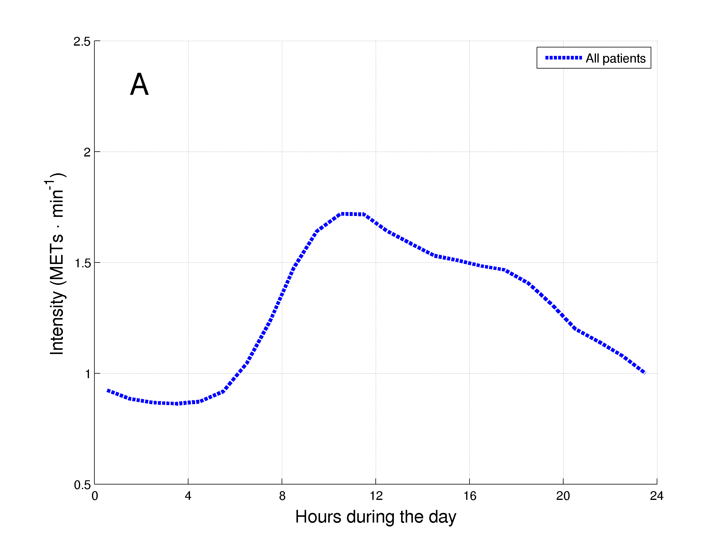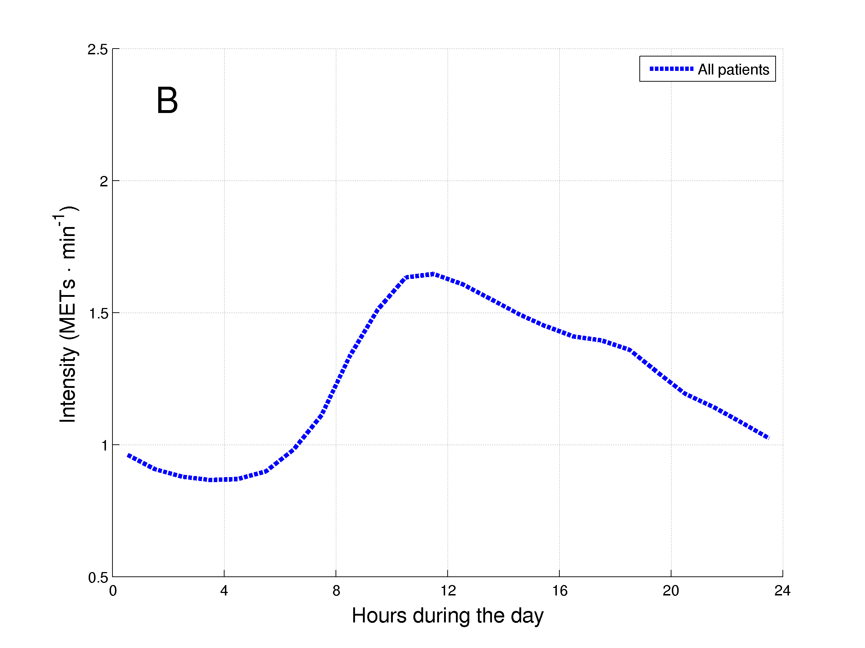

***Figure 1.*** Daily hourly pattern of the 1001 patients with COPD during weekdays (A) and weekend days (B).

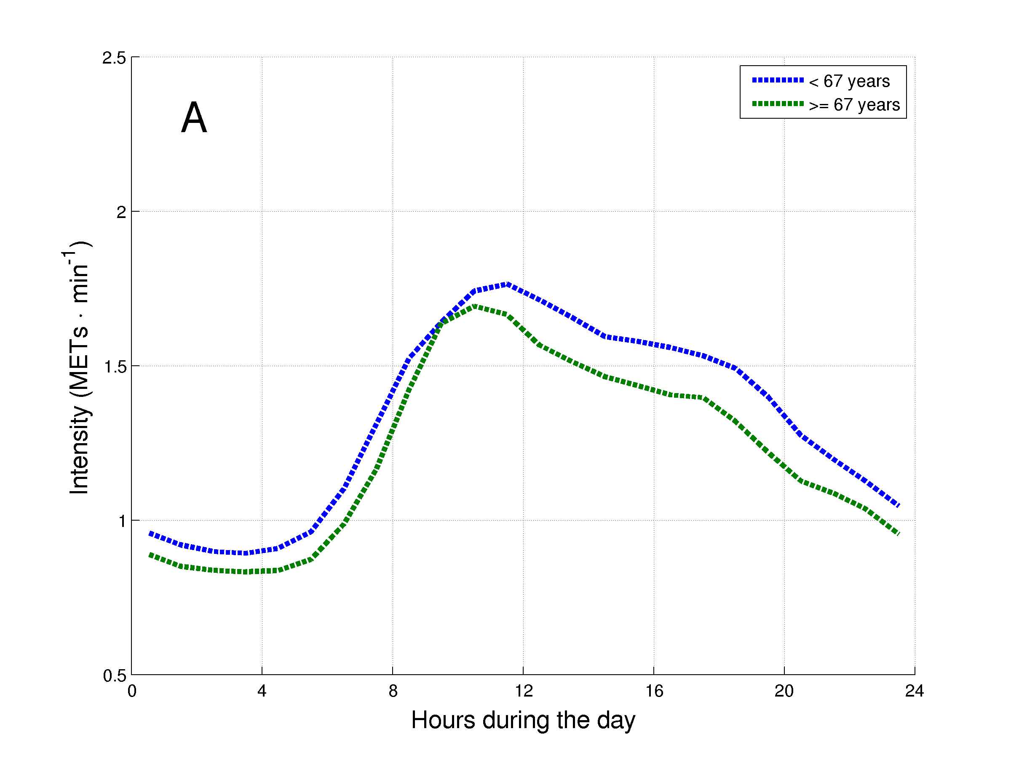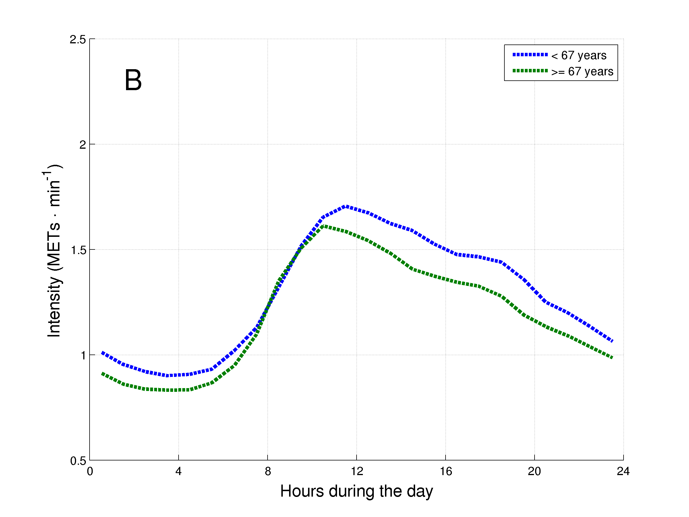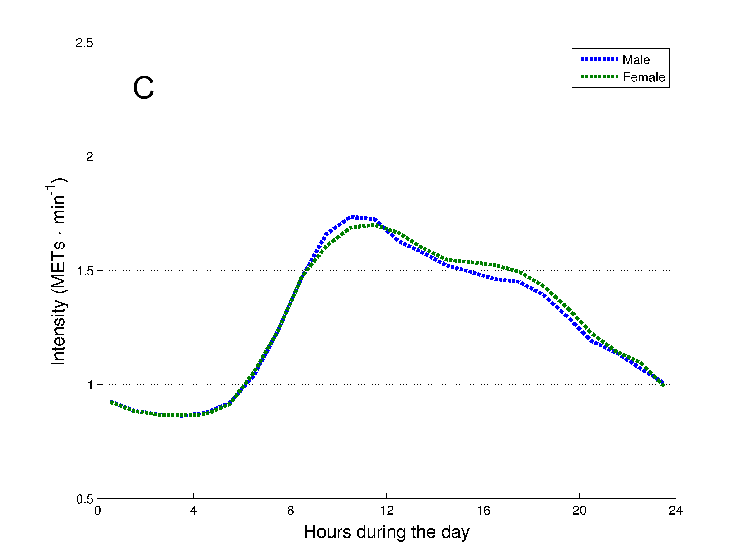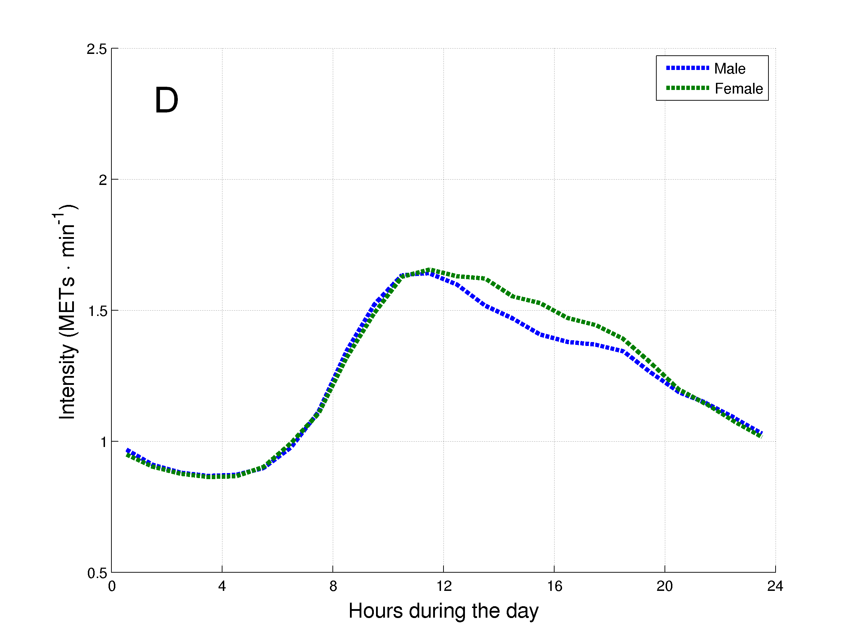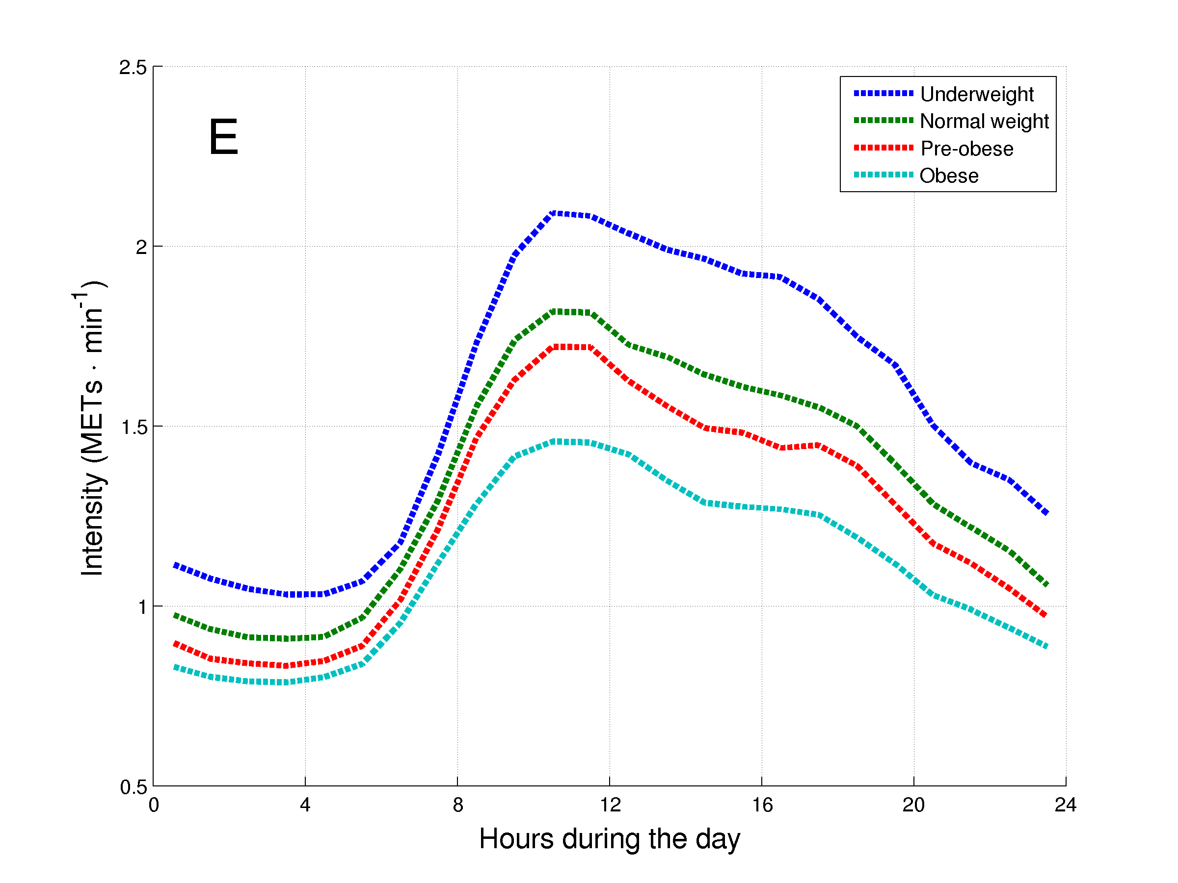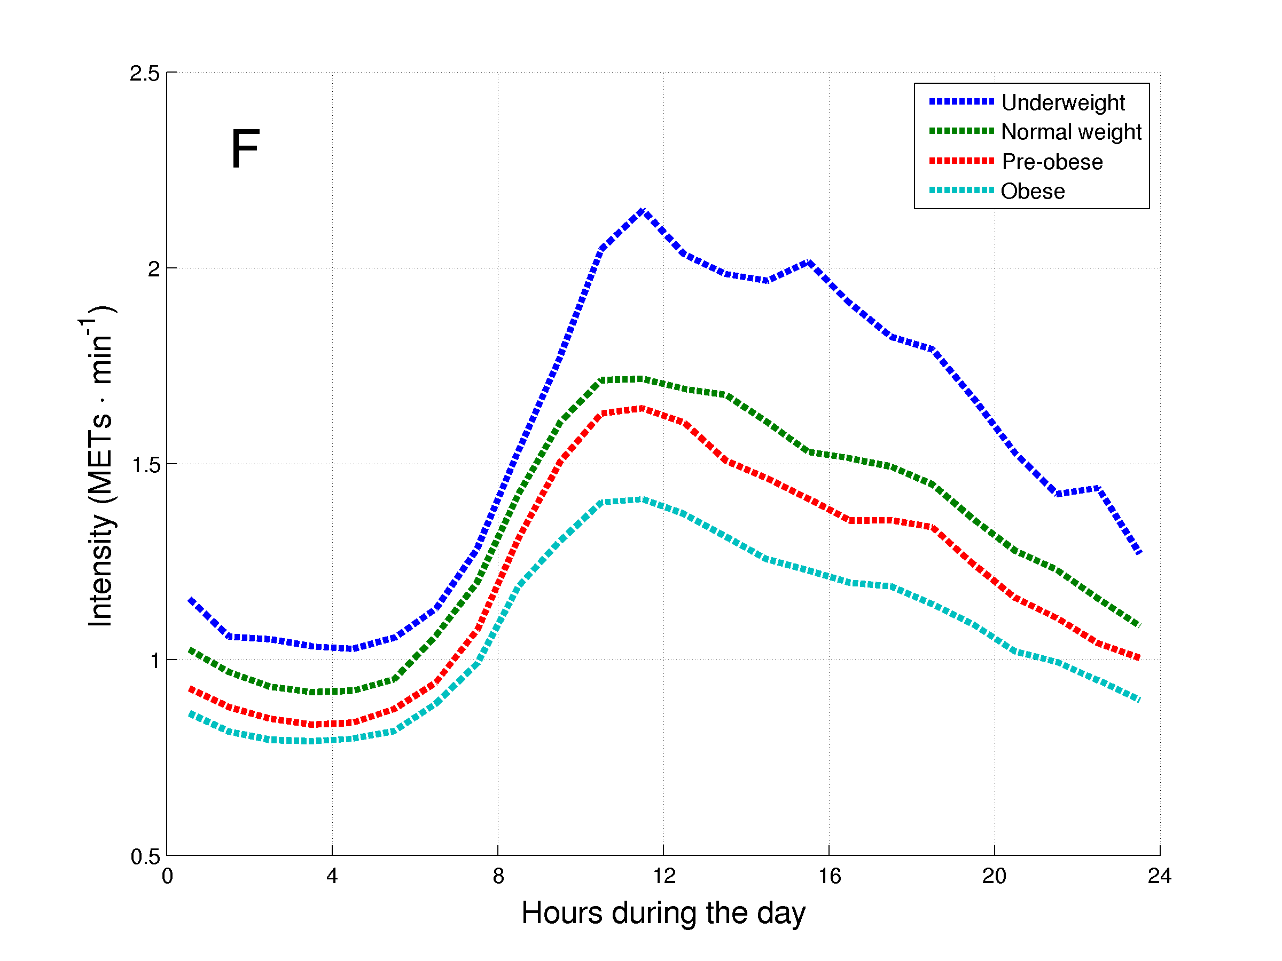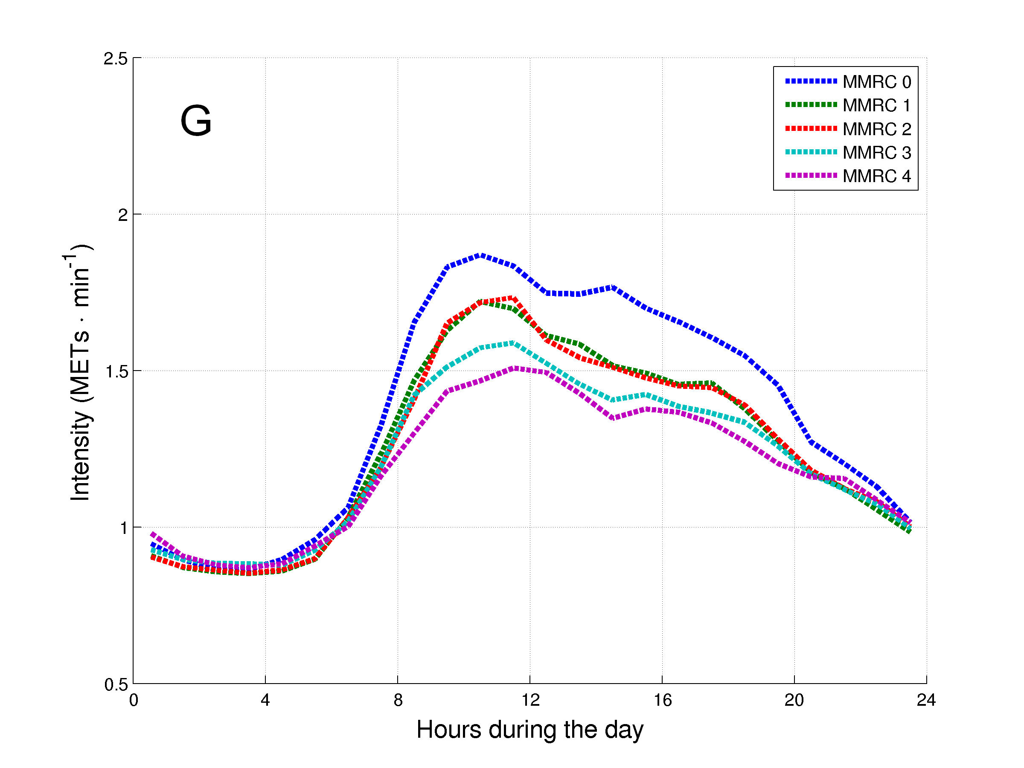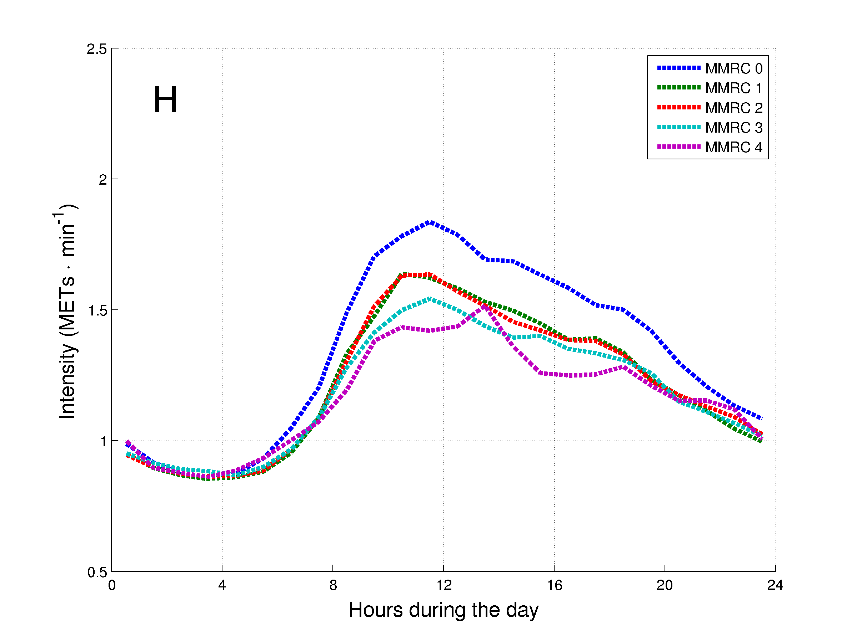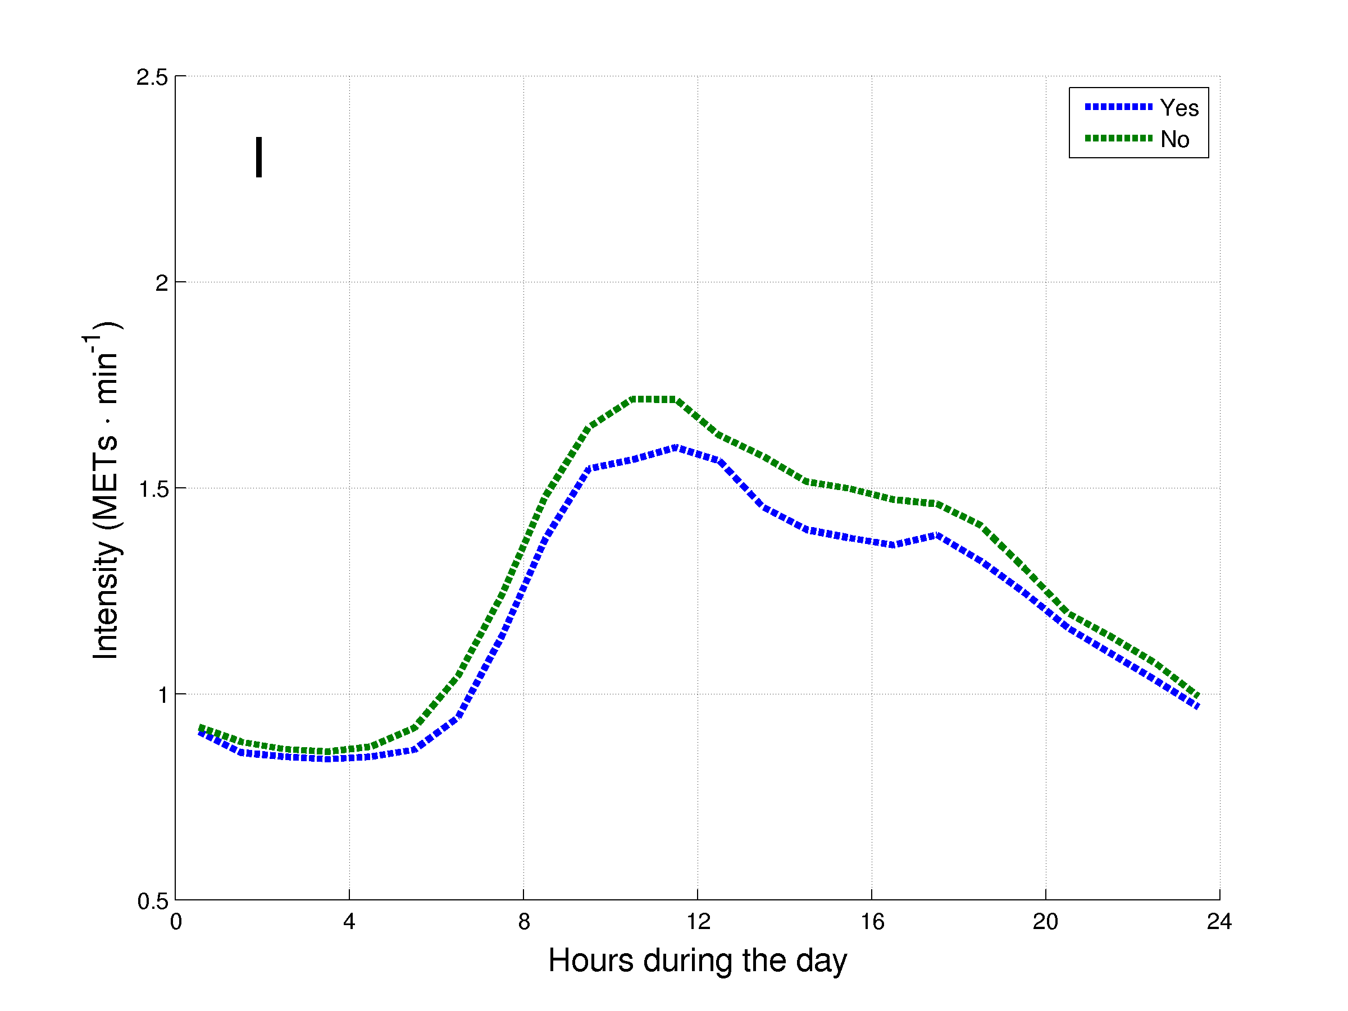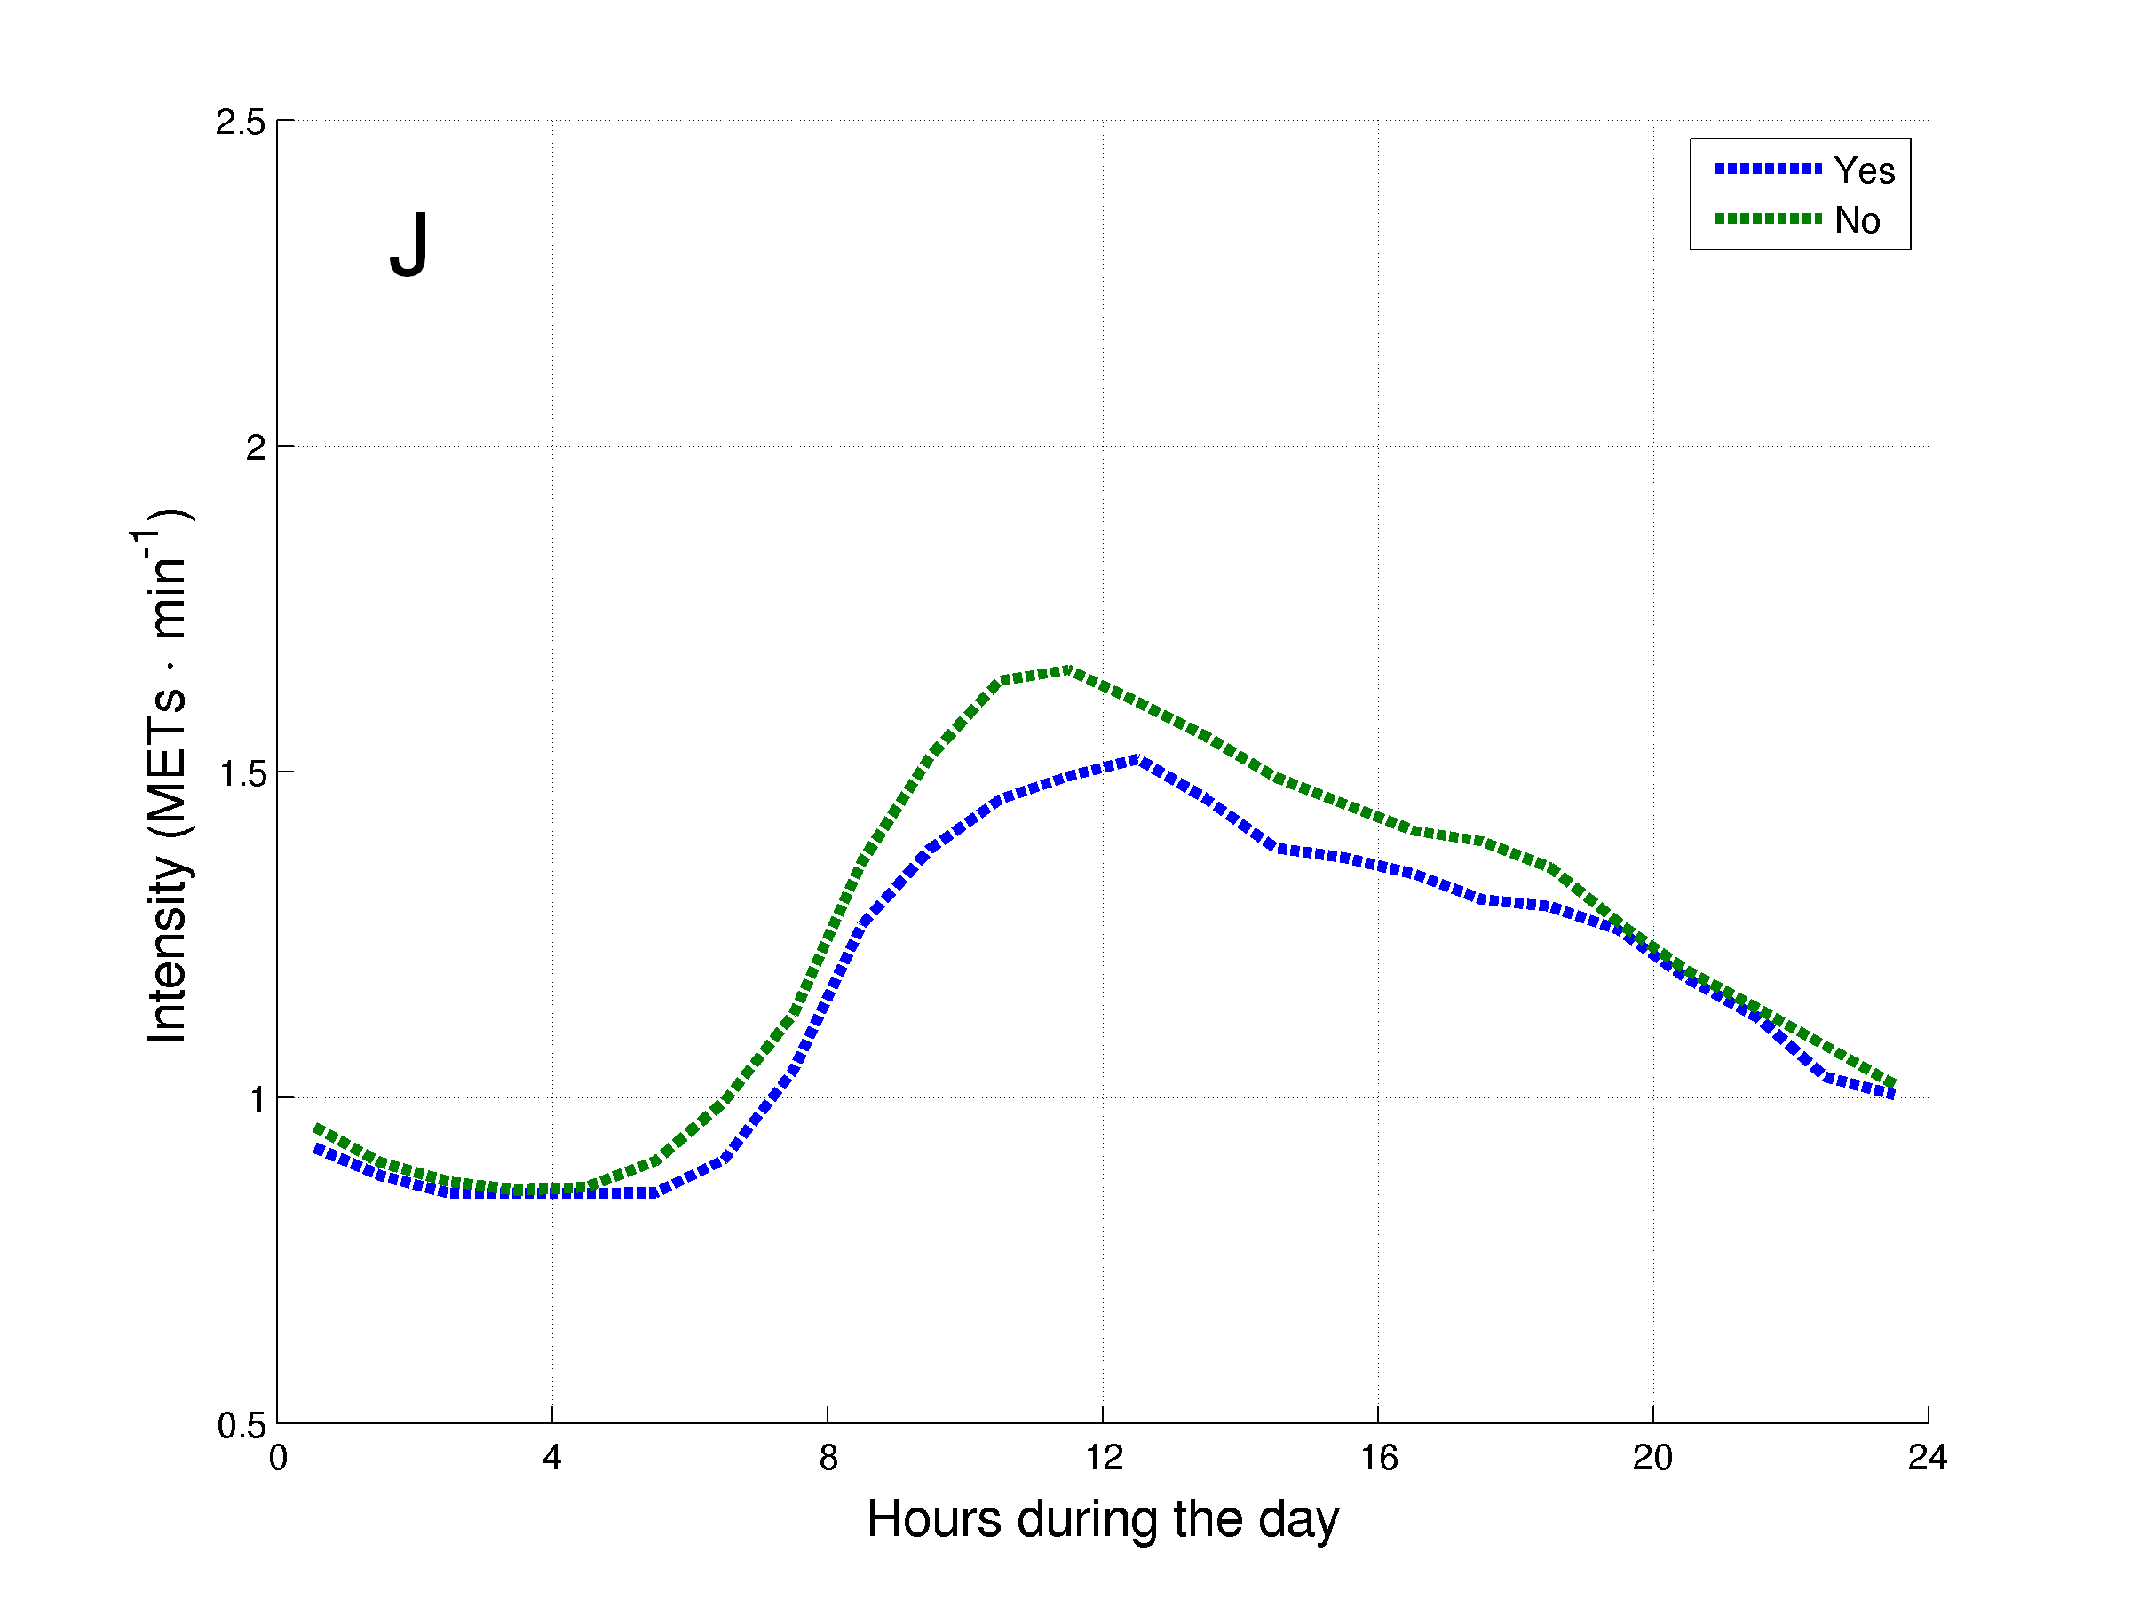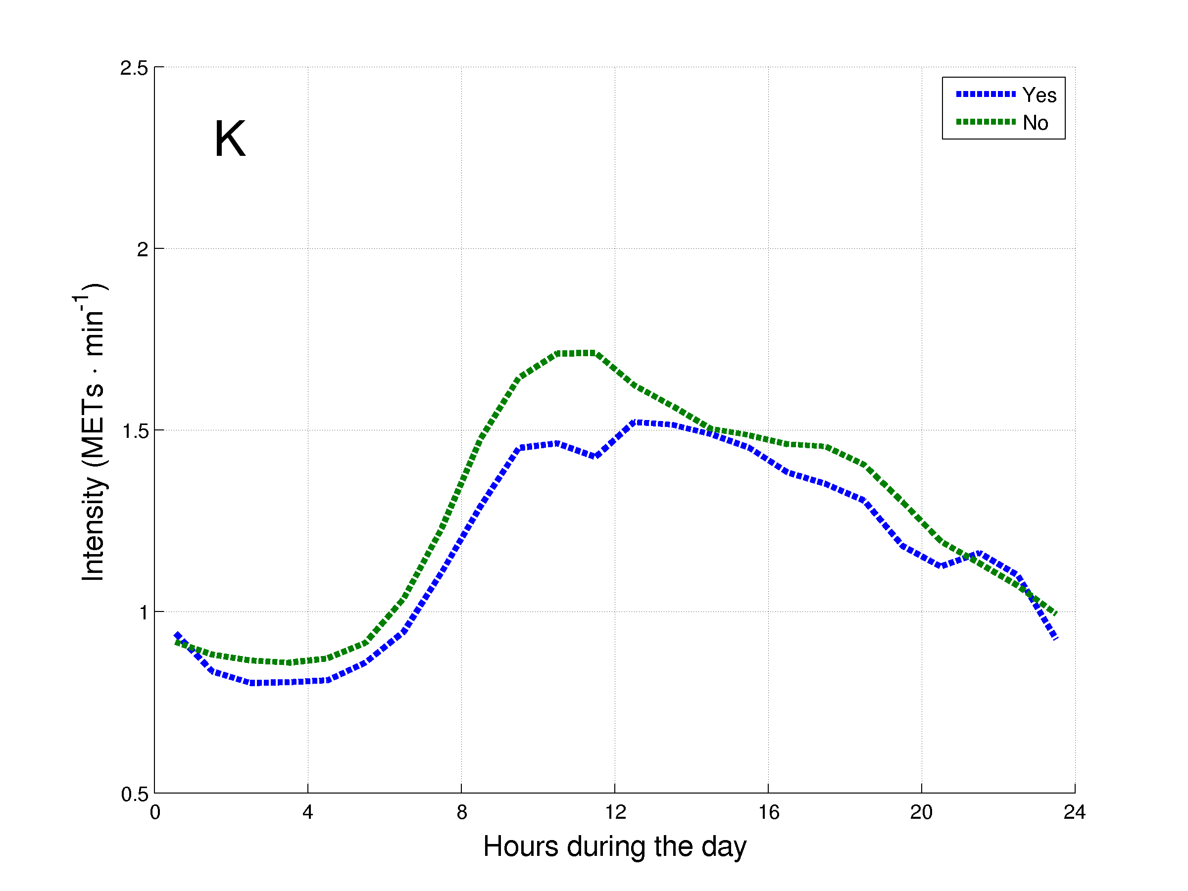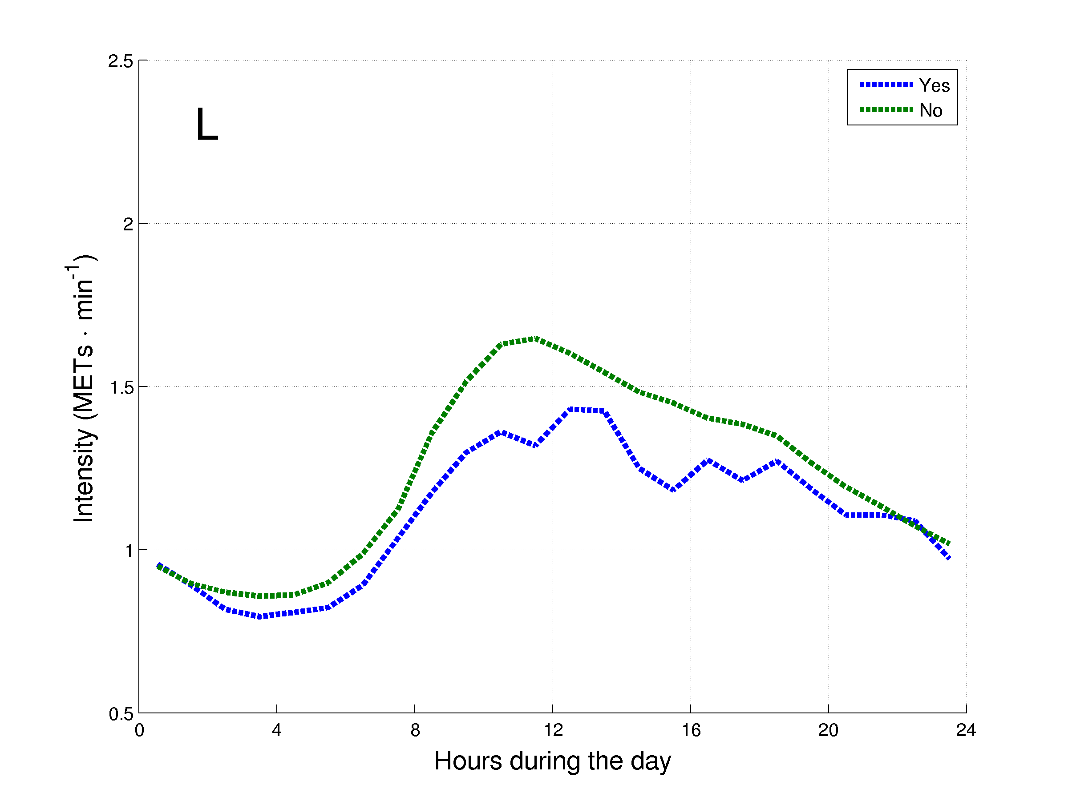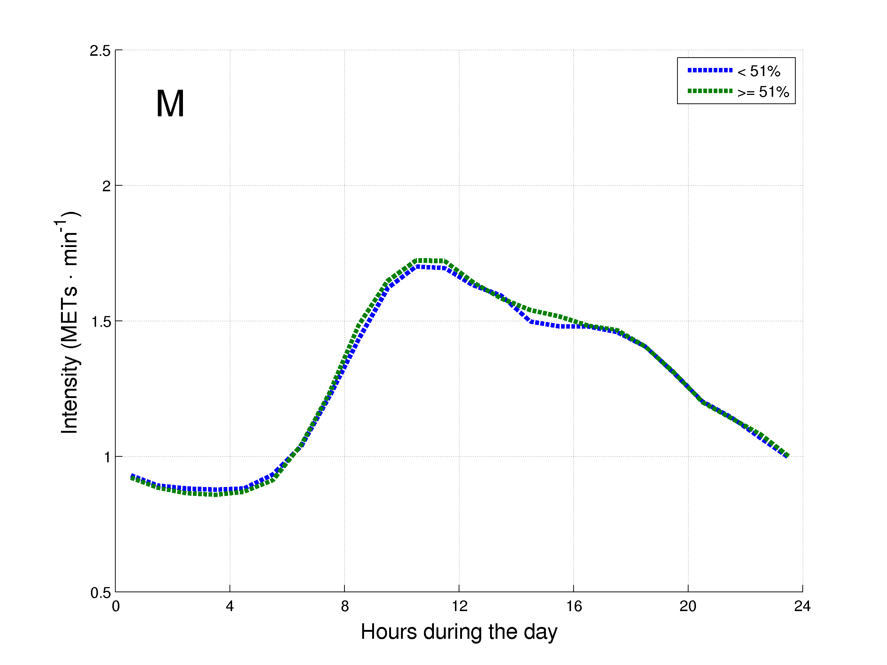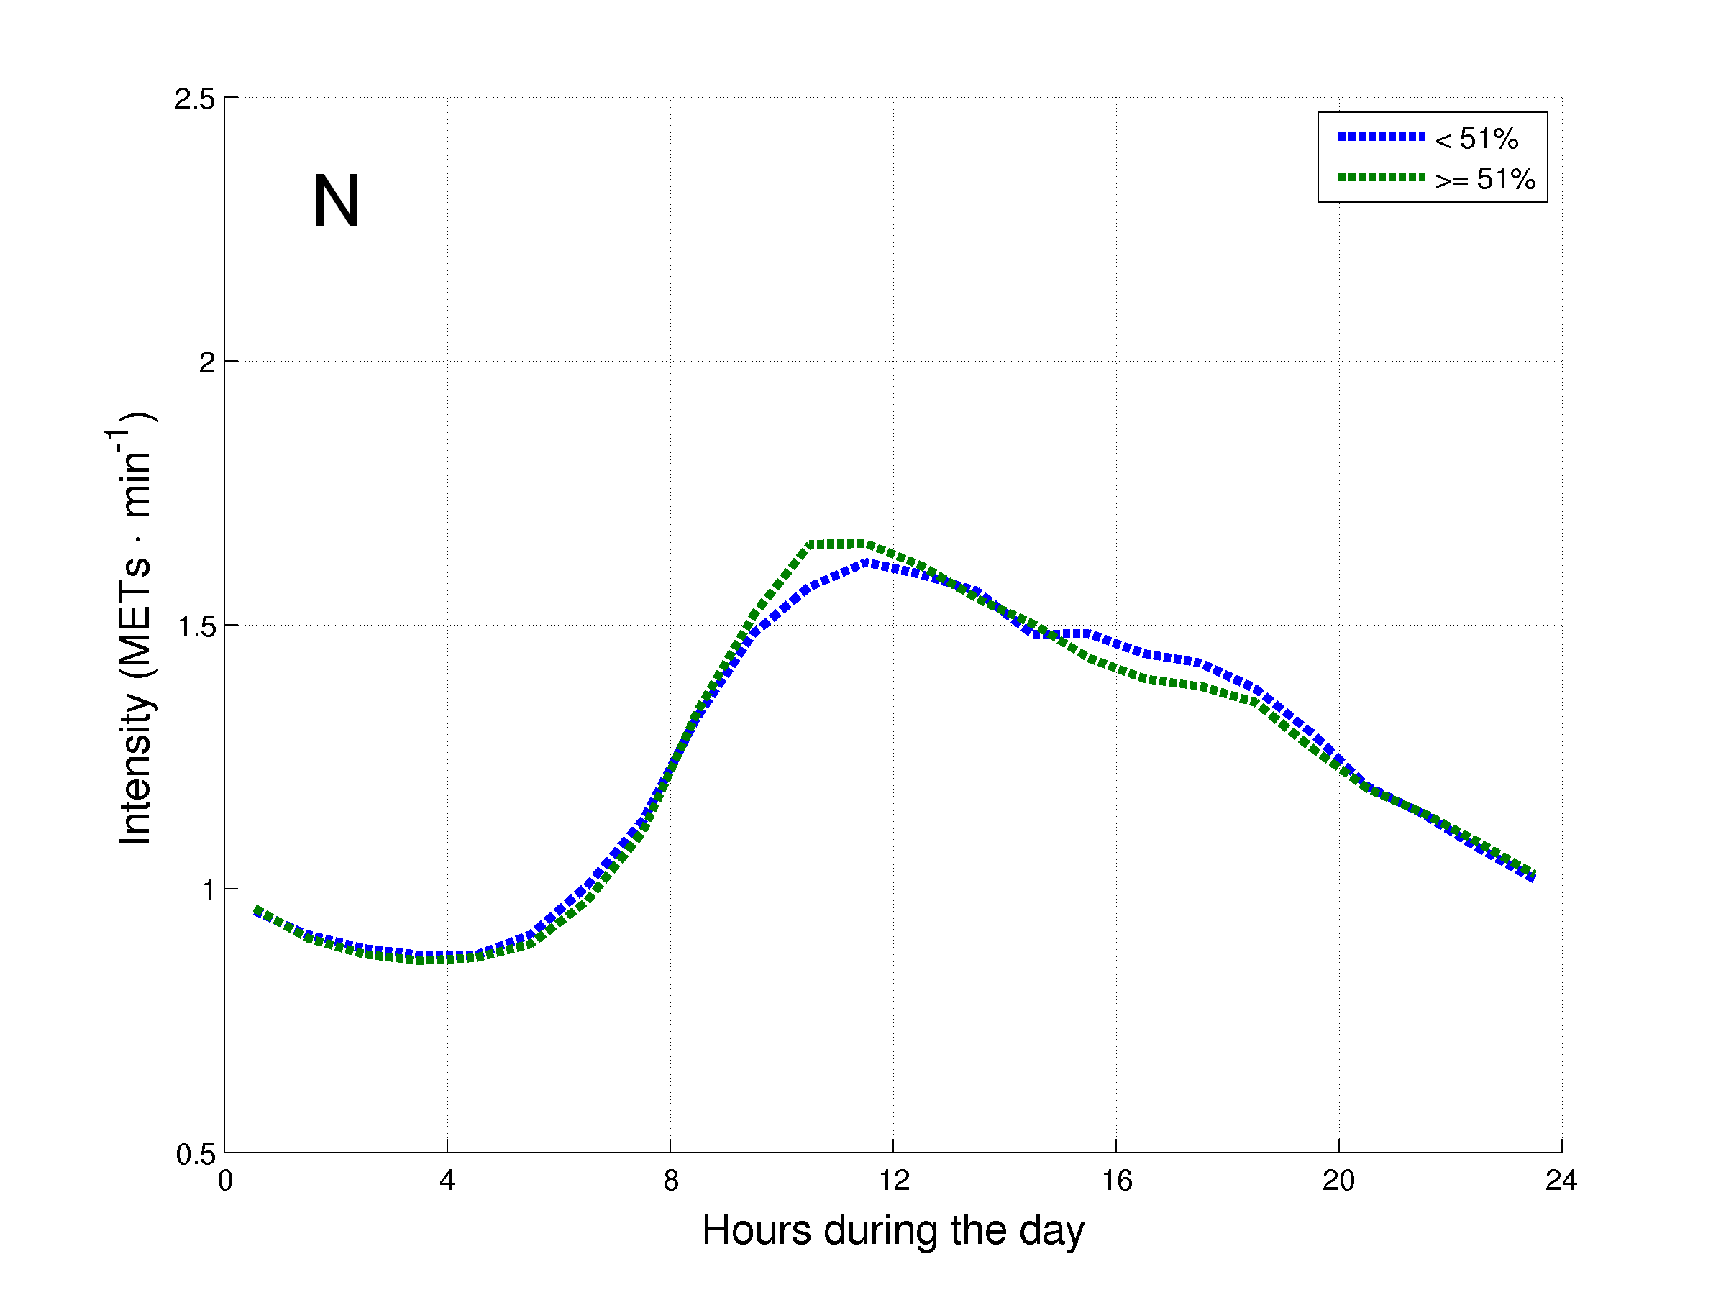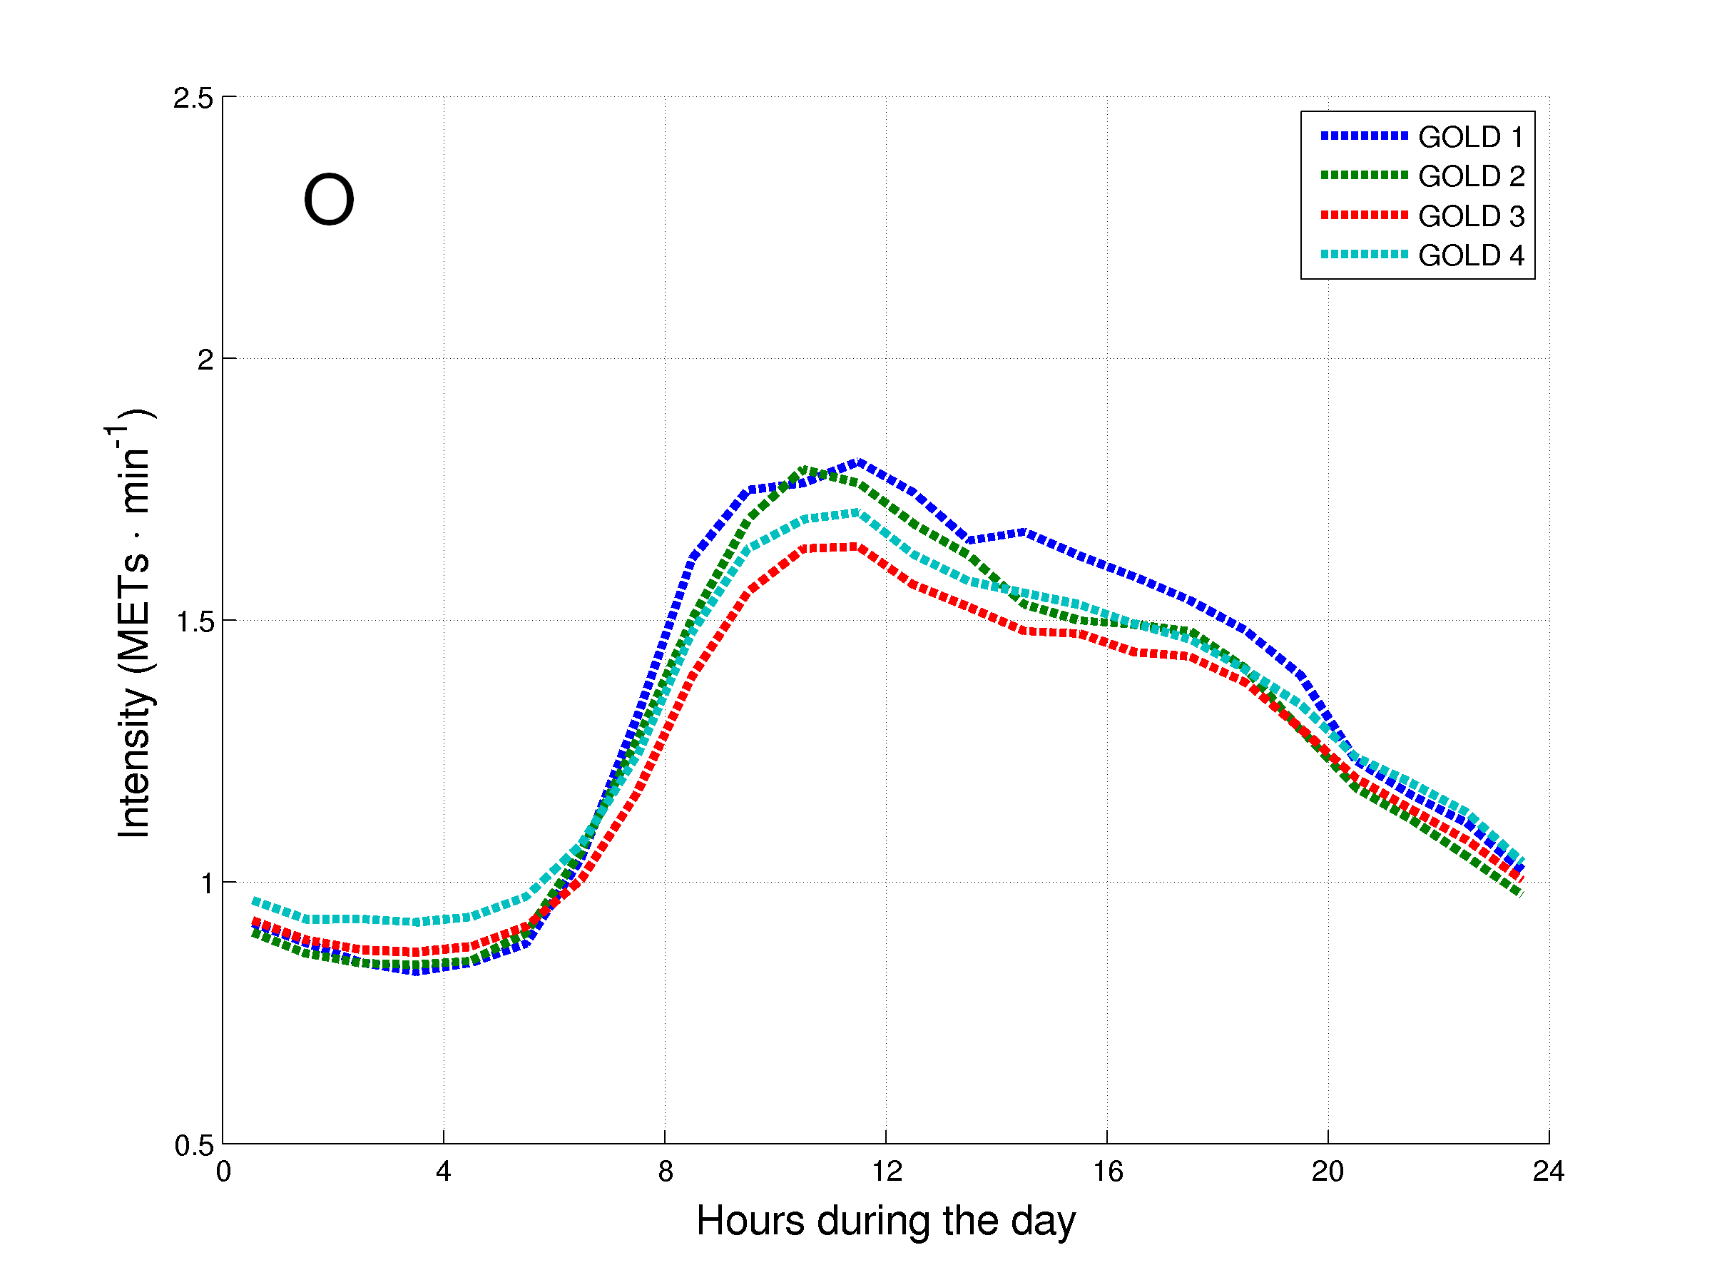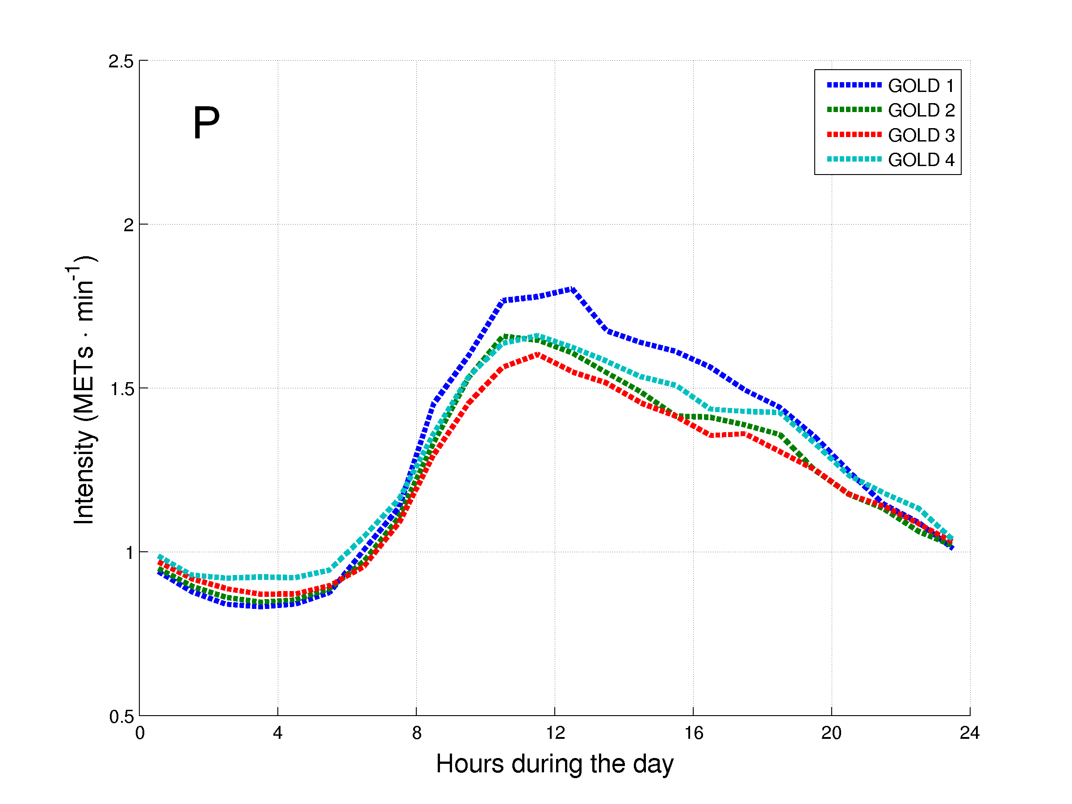

*Figure 2. Daily hourly pattern of the patients with COPD after stratification for general characteristics during weekdays (A, C, E, G, I, K, M and O) and weekend days (B, D, F, H, J, L, N and P). The daily hourly pattern was stratified for: A and B – age groups; C and D – gender; E and F – body mass index (BMI) classification; G and H – modified Medical Research Council (mMRC) grades; I and J – long-term oxygen therapy (LTOT) use; K and L – walking aids use; M and N – diffusion capacity of the lung for carbon monoxide (DLCO) groups; and O and P – Global Initiative for Chronic Obstructive Lung Disease (GOLD) grades.*

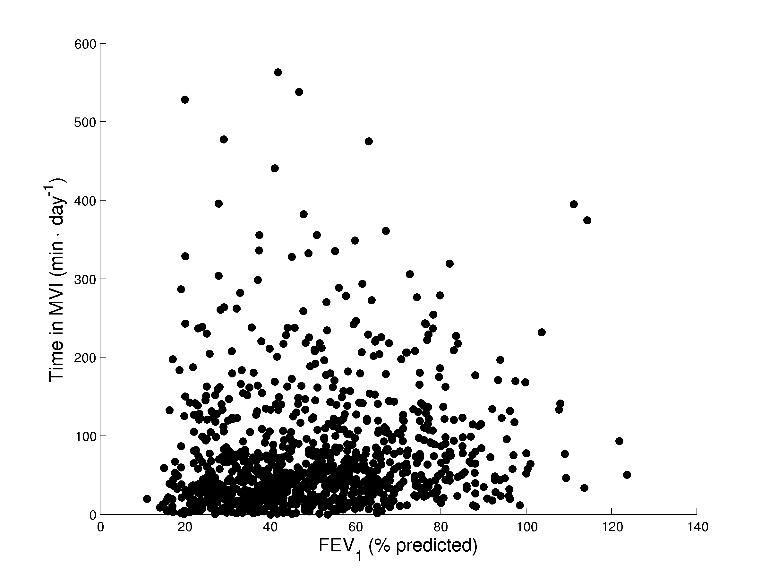

***Figure 3.*** Spearman’s correlation between the degree of airflow limitation and the daily time in MVI for 1001 patients with COPD.

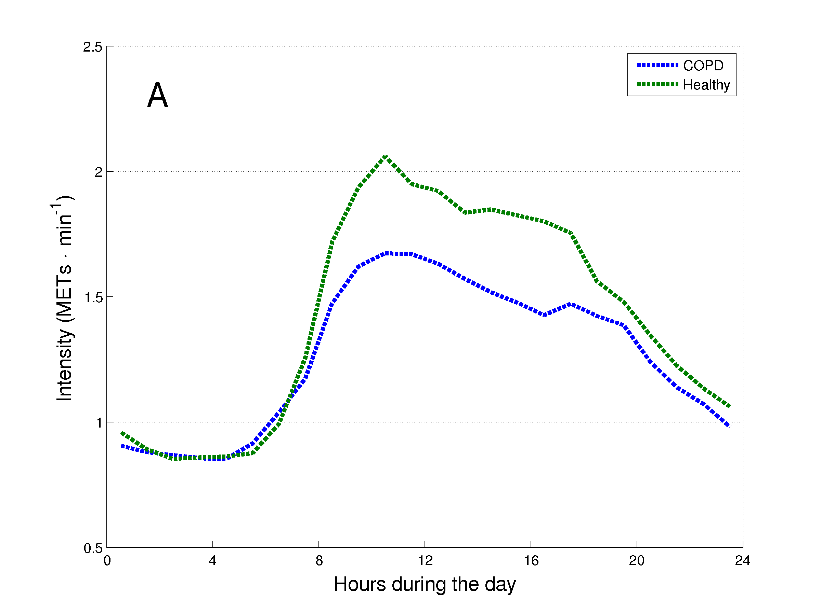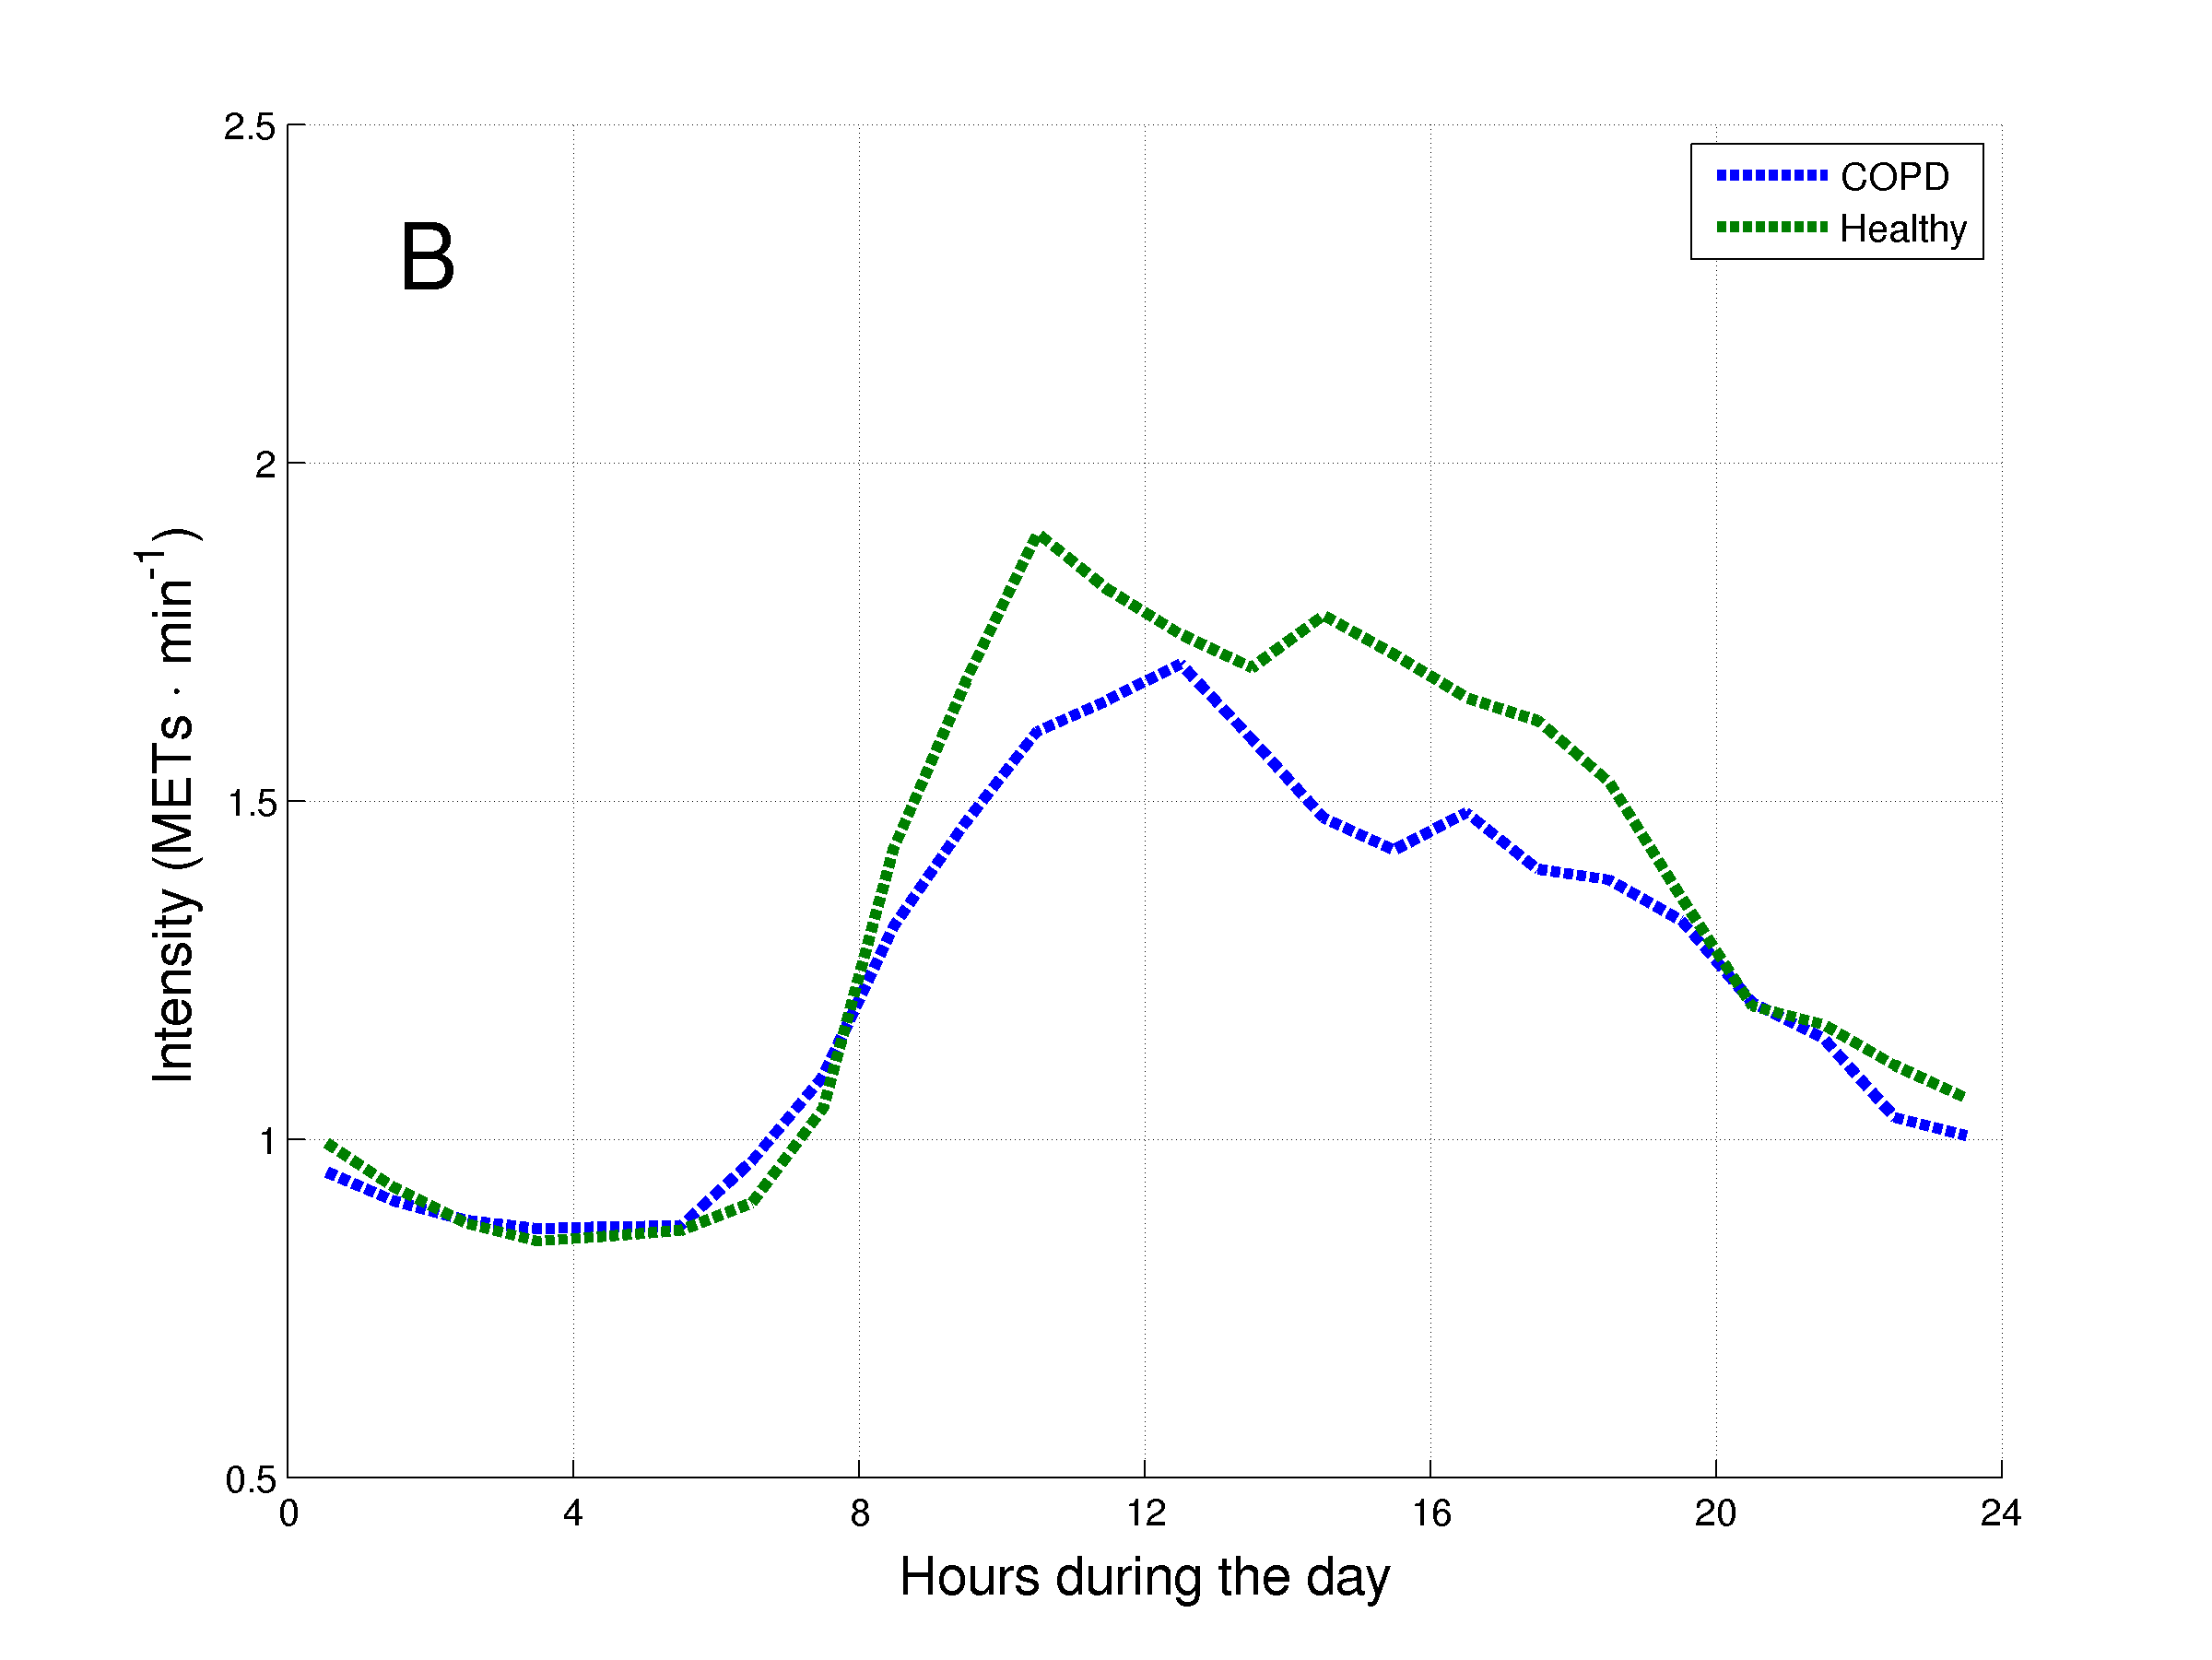

***Figure 4.*** Daily hourly pattern of healthy subjects and matched patients with COPD during weekdays (A) and weekend days (B).

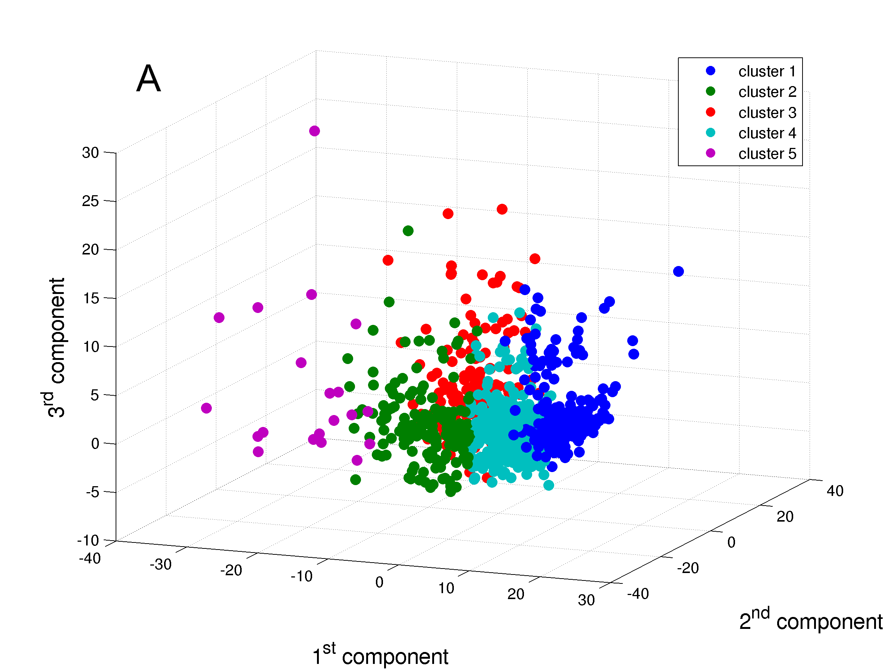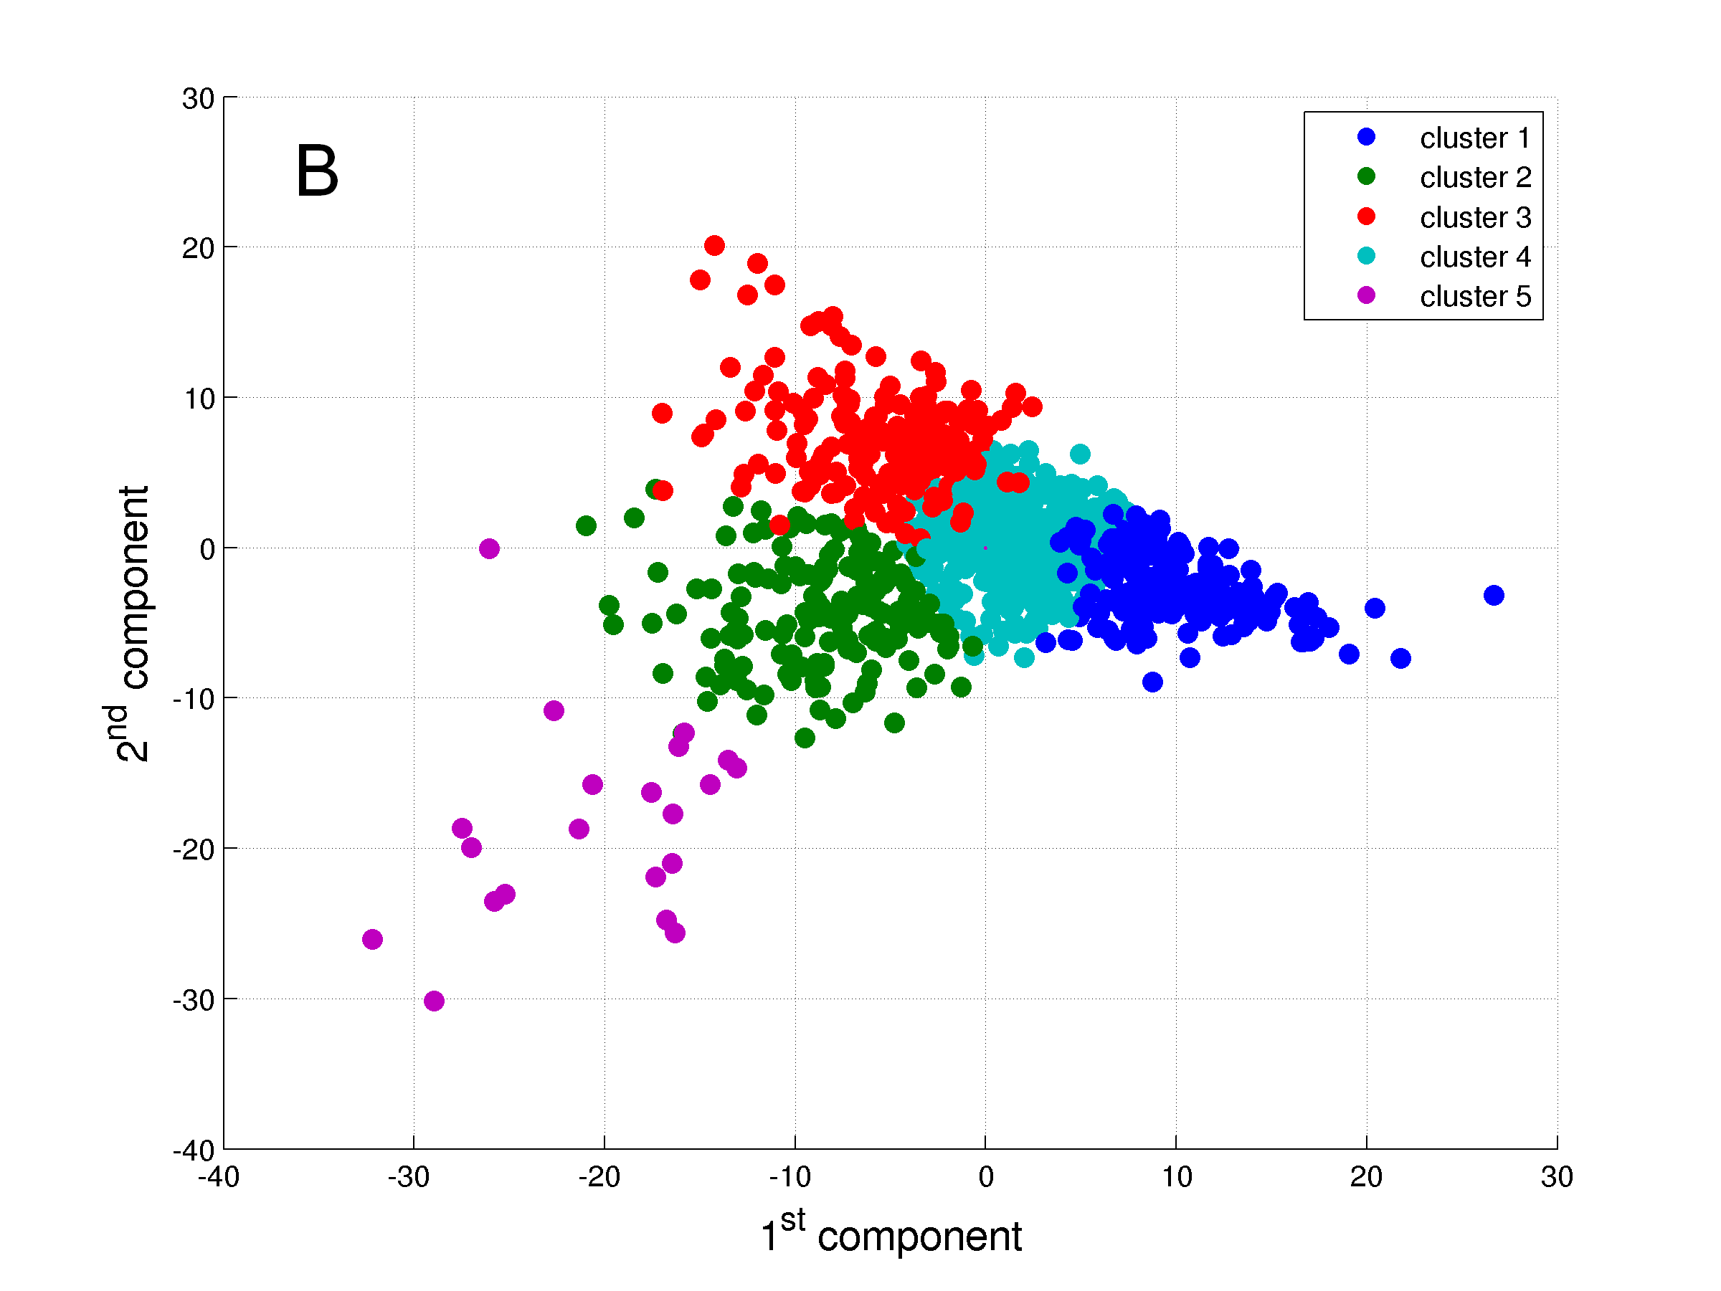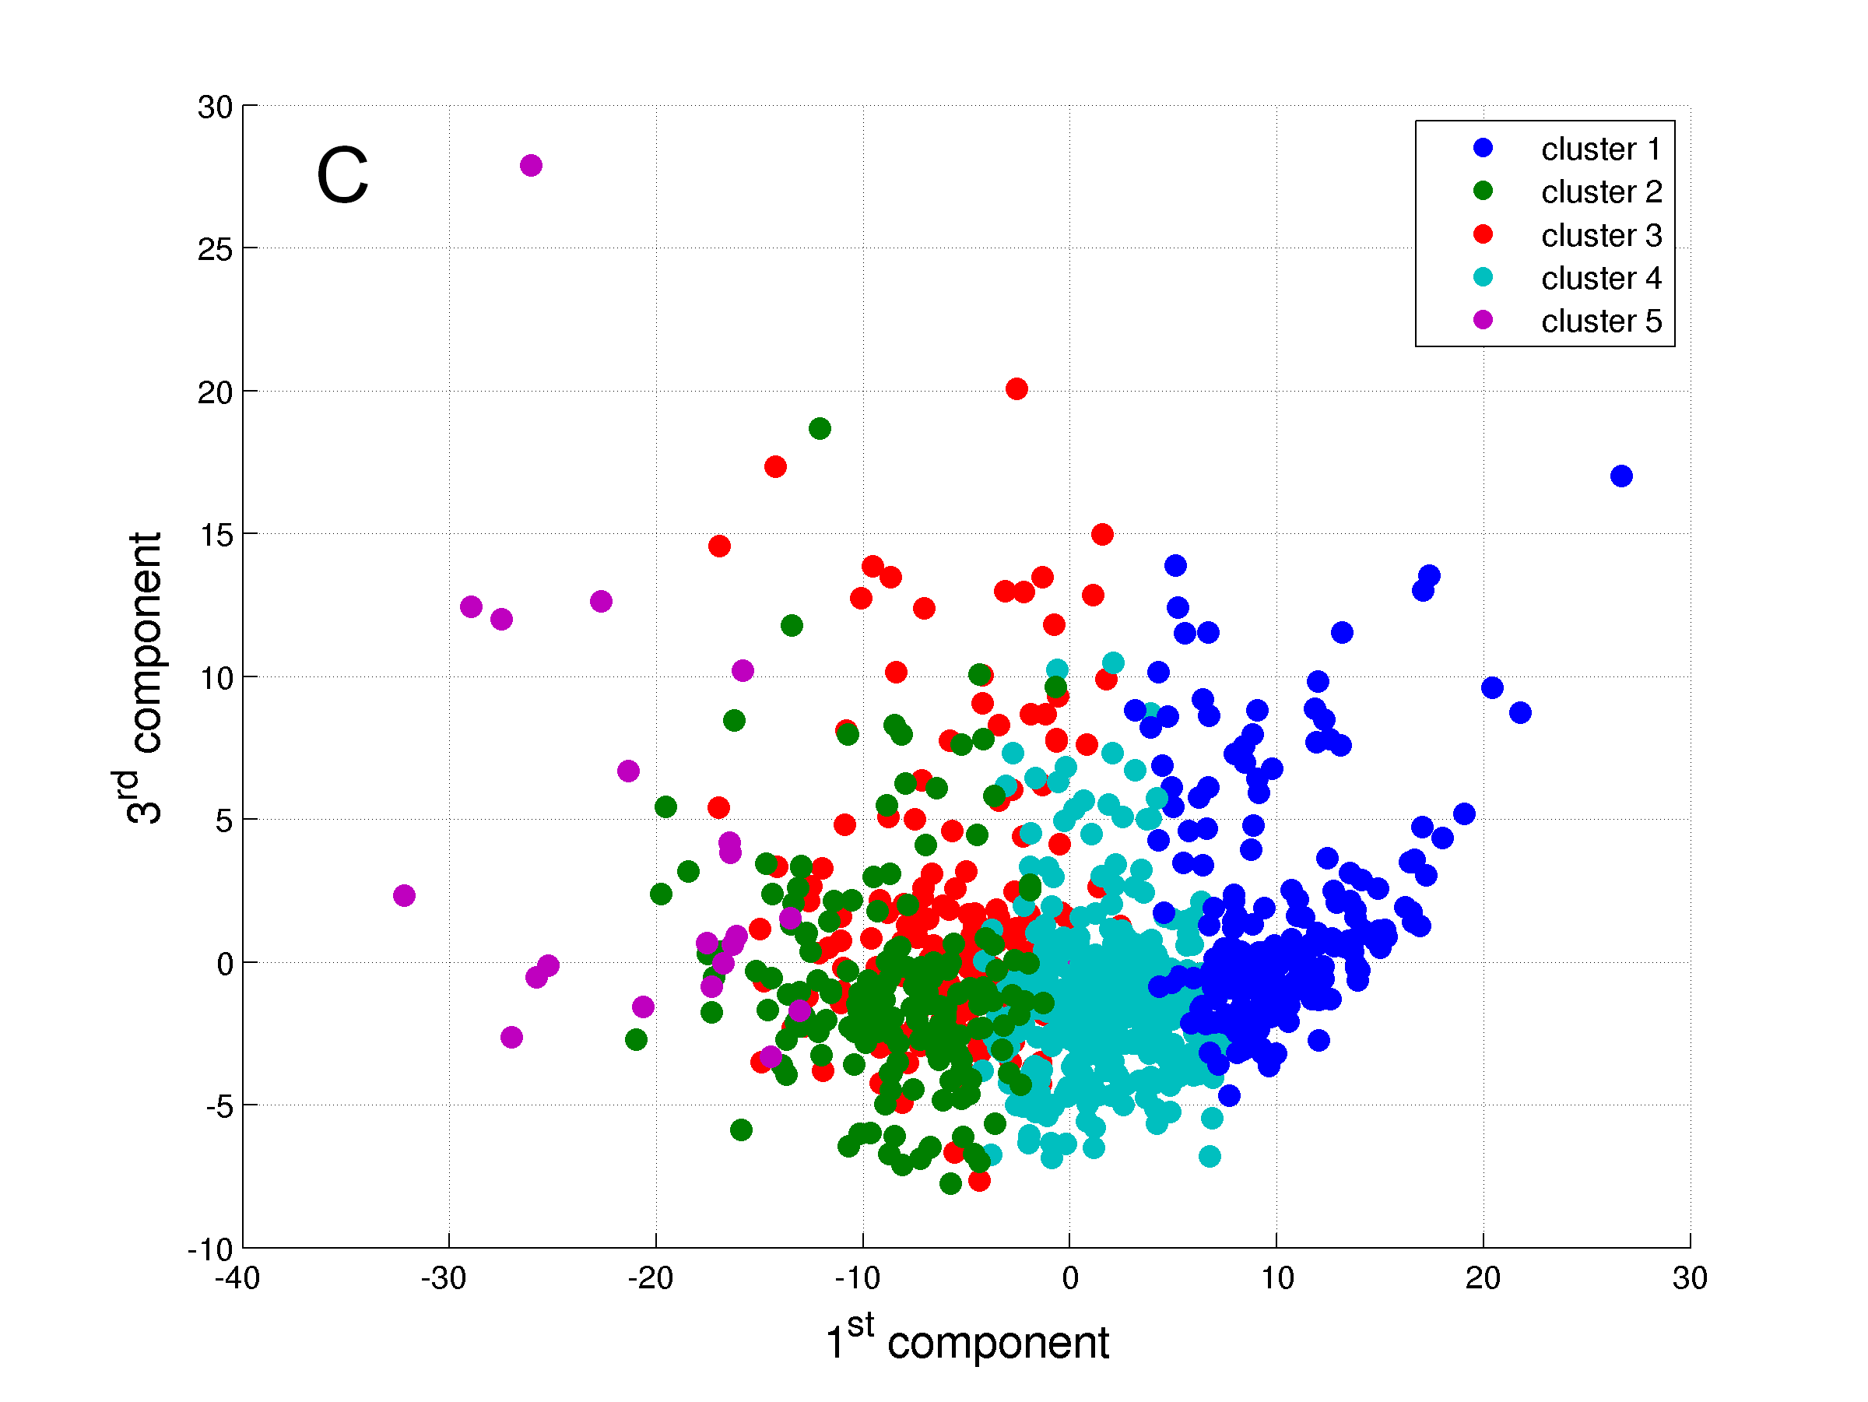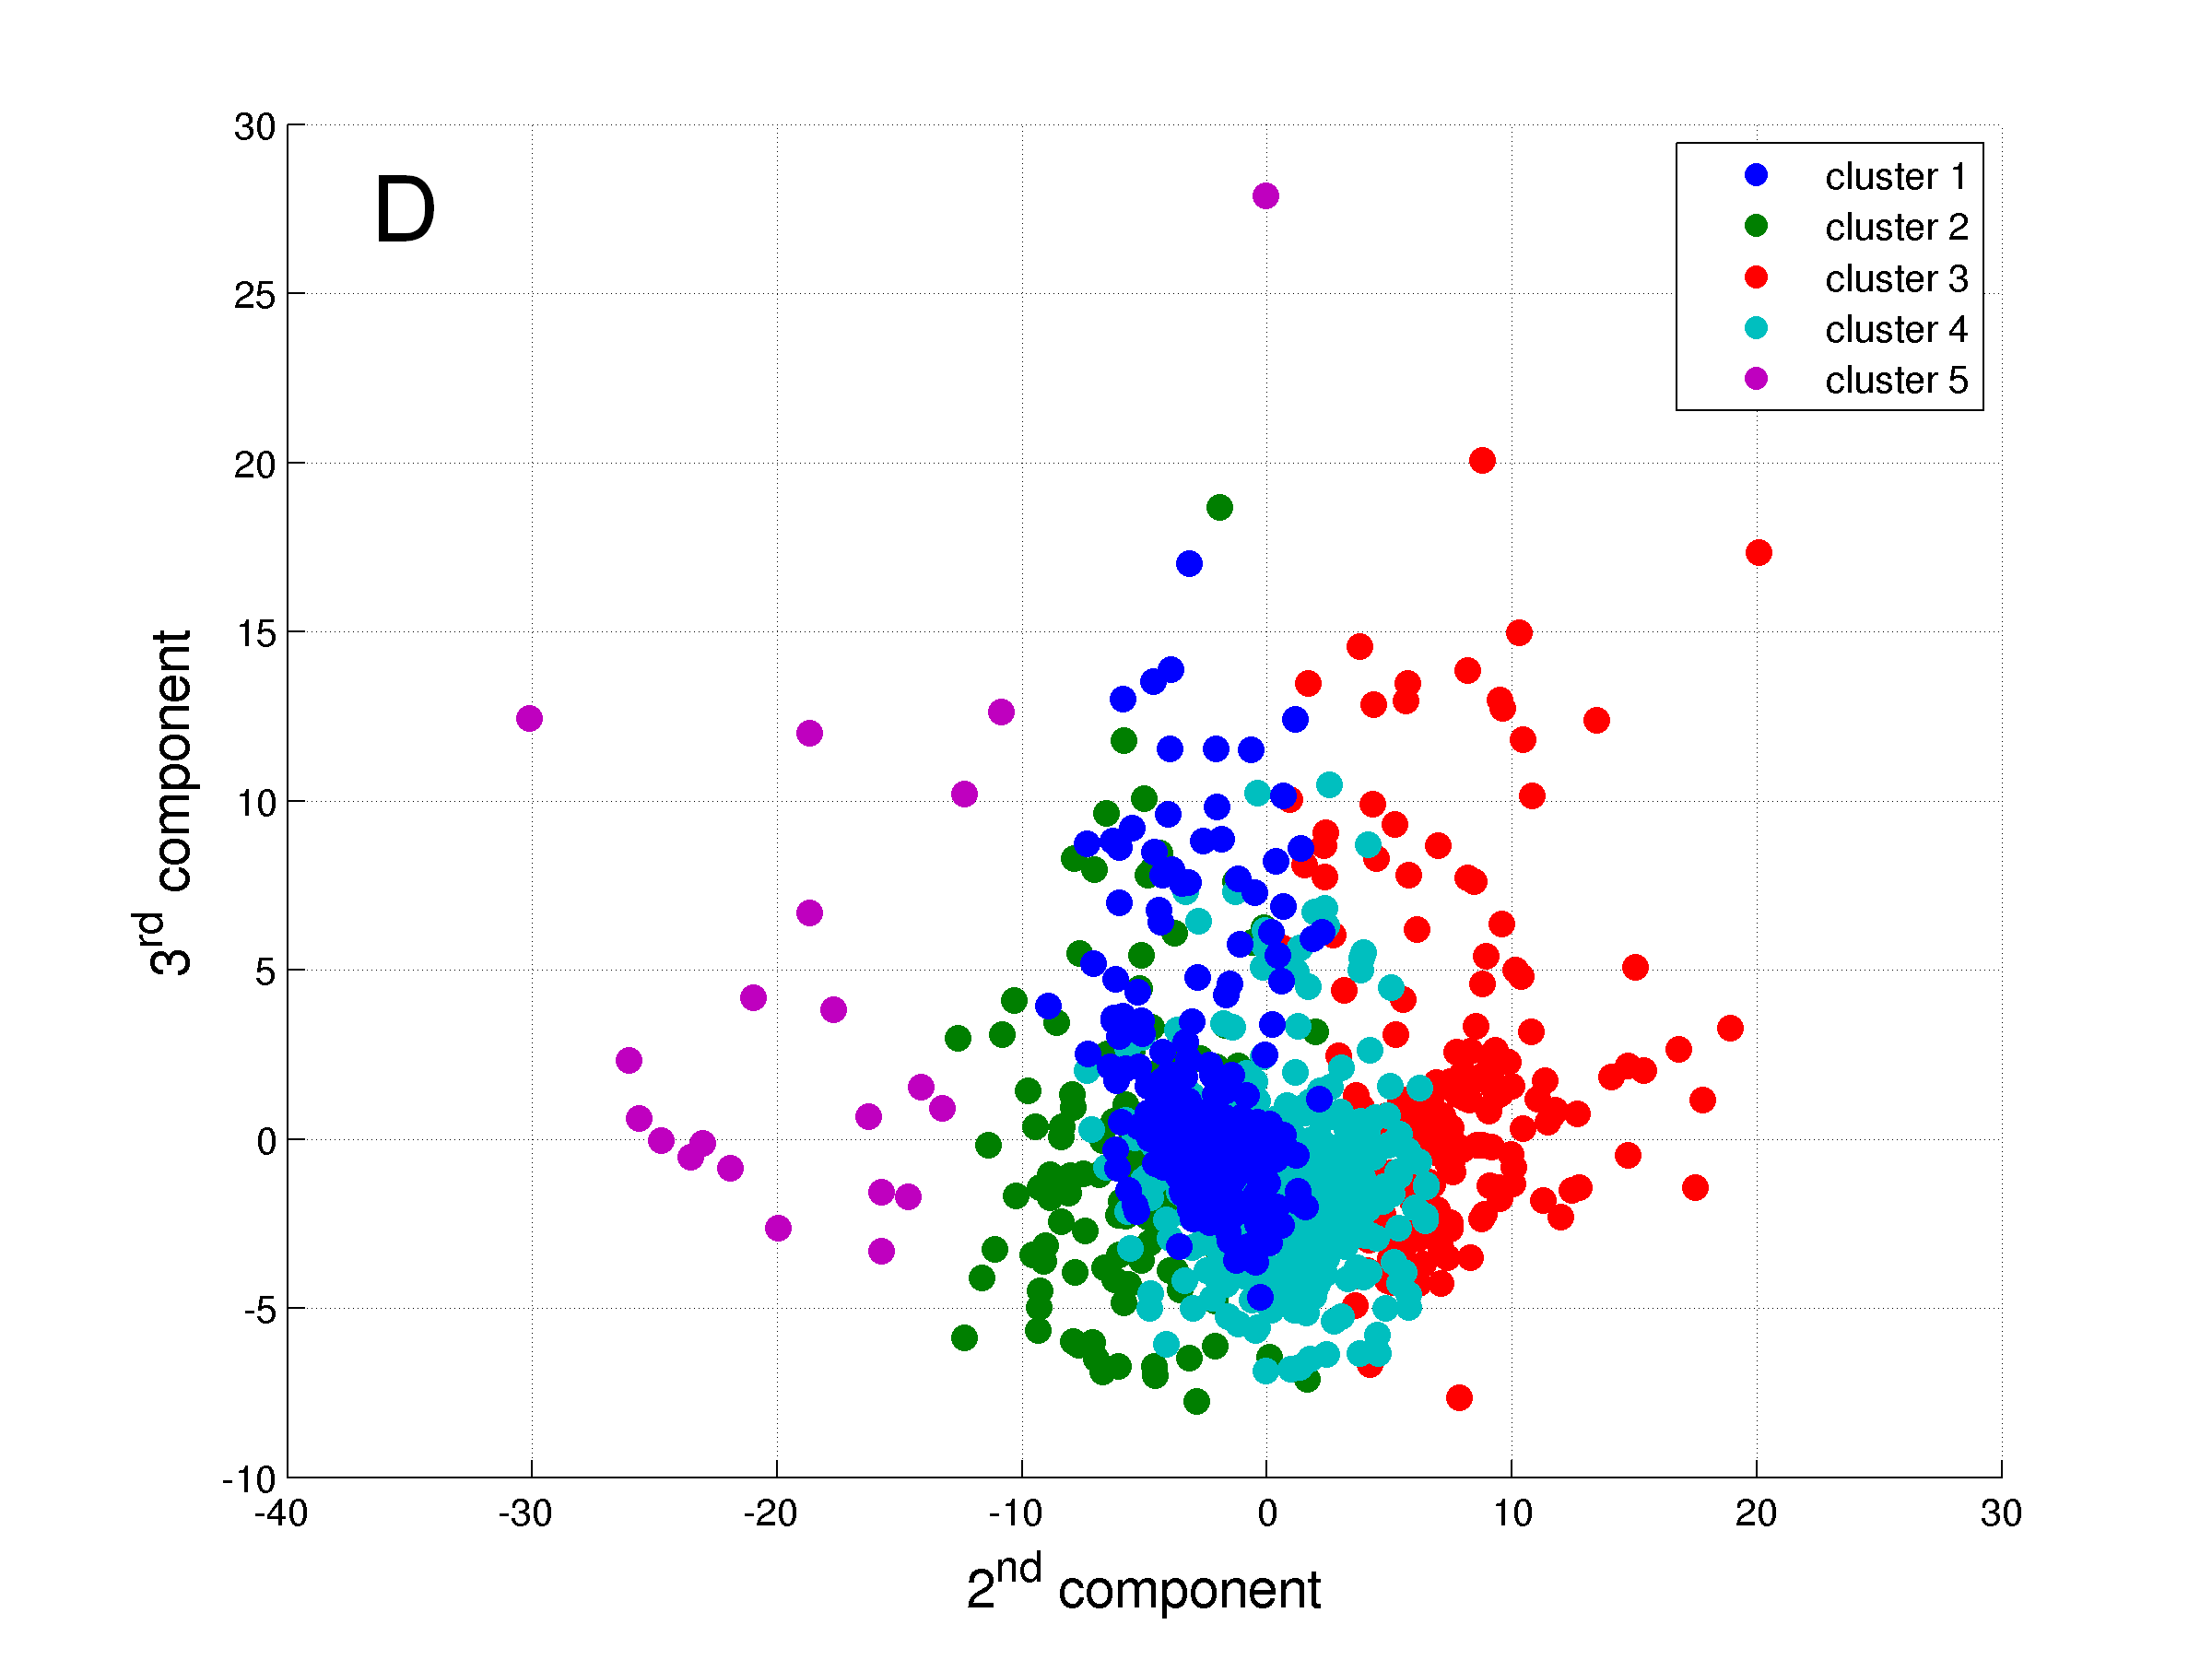

***Figure 5.*** The five clusters identified. A: Graph in 3 dimensions presenting the three components from the PCA; B: Graph in 2 dimensions presenting the 1st and 2nd components; C: Graph in 2 dimensions presenting the 1st and 3rd components; and D: Graph in 2 dimensions presenting the 2nd and 3rd components.

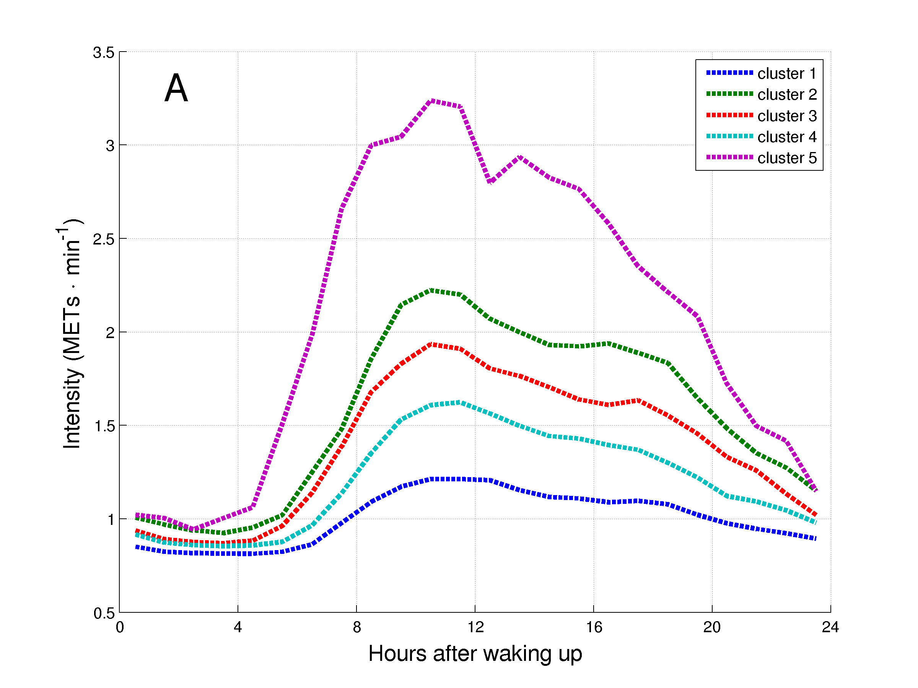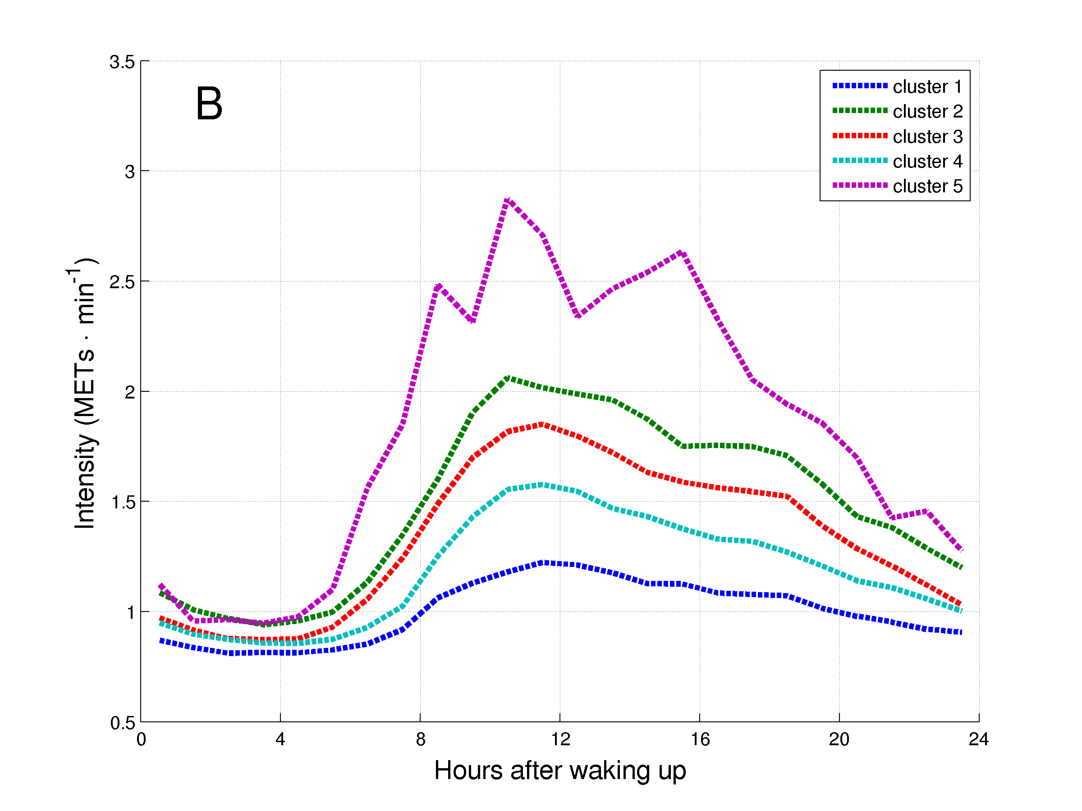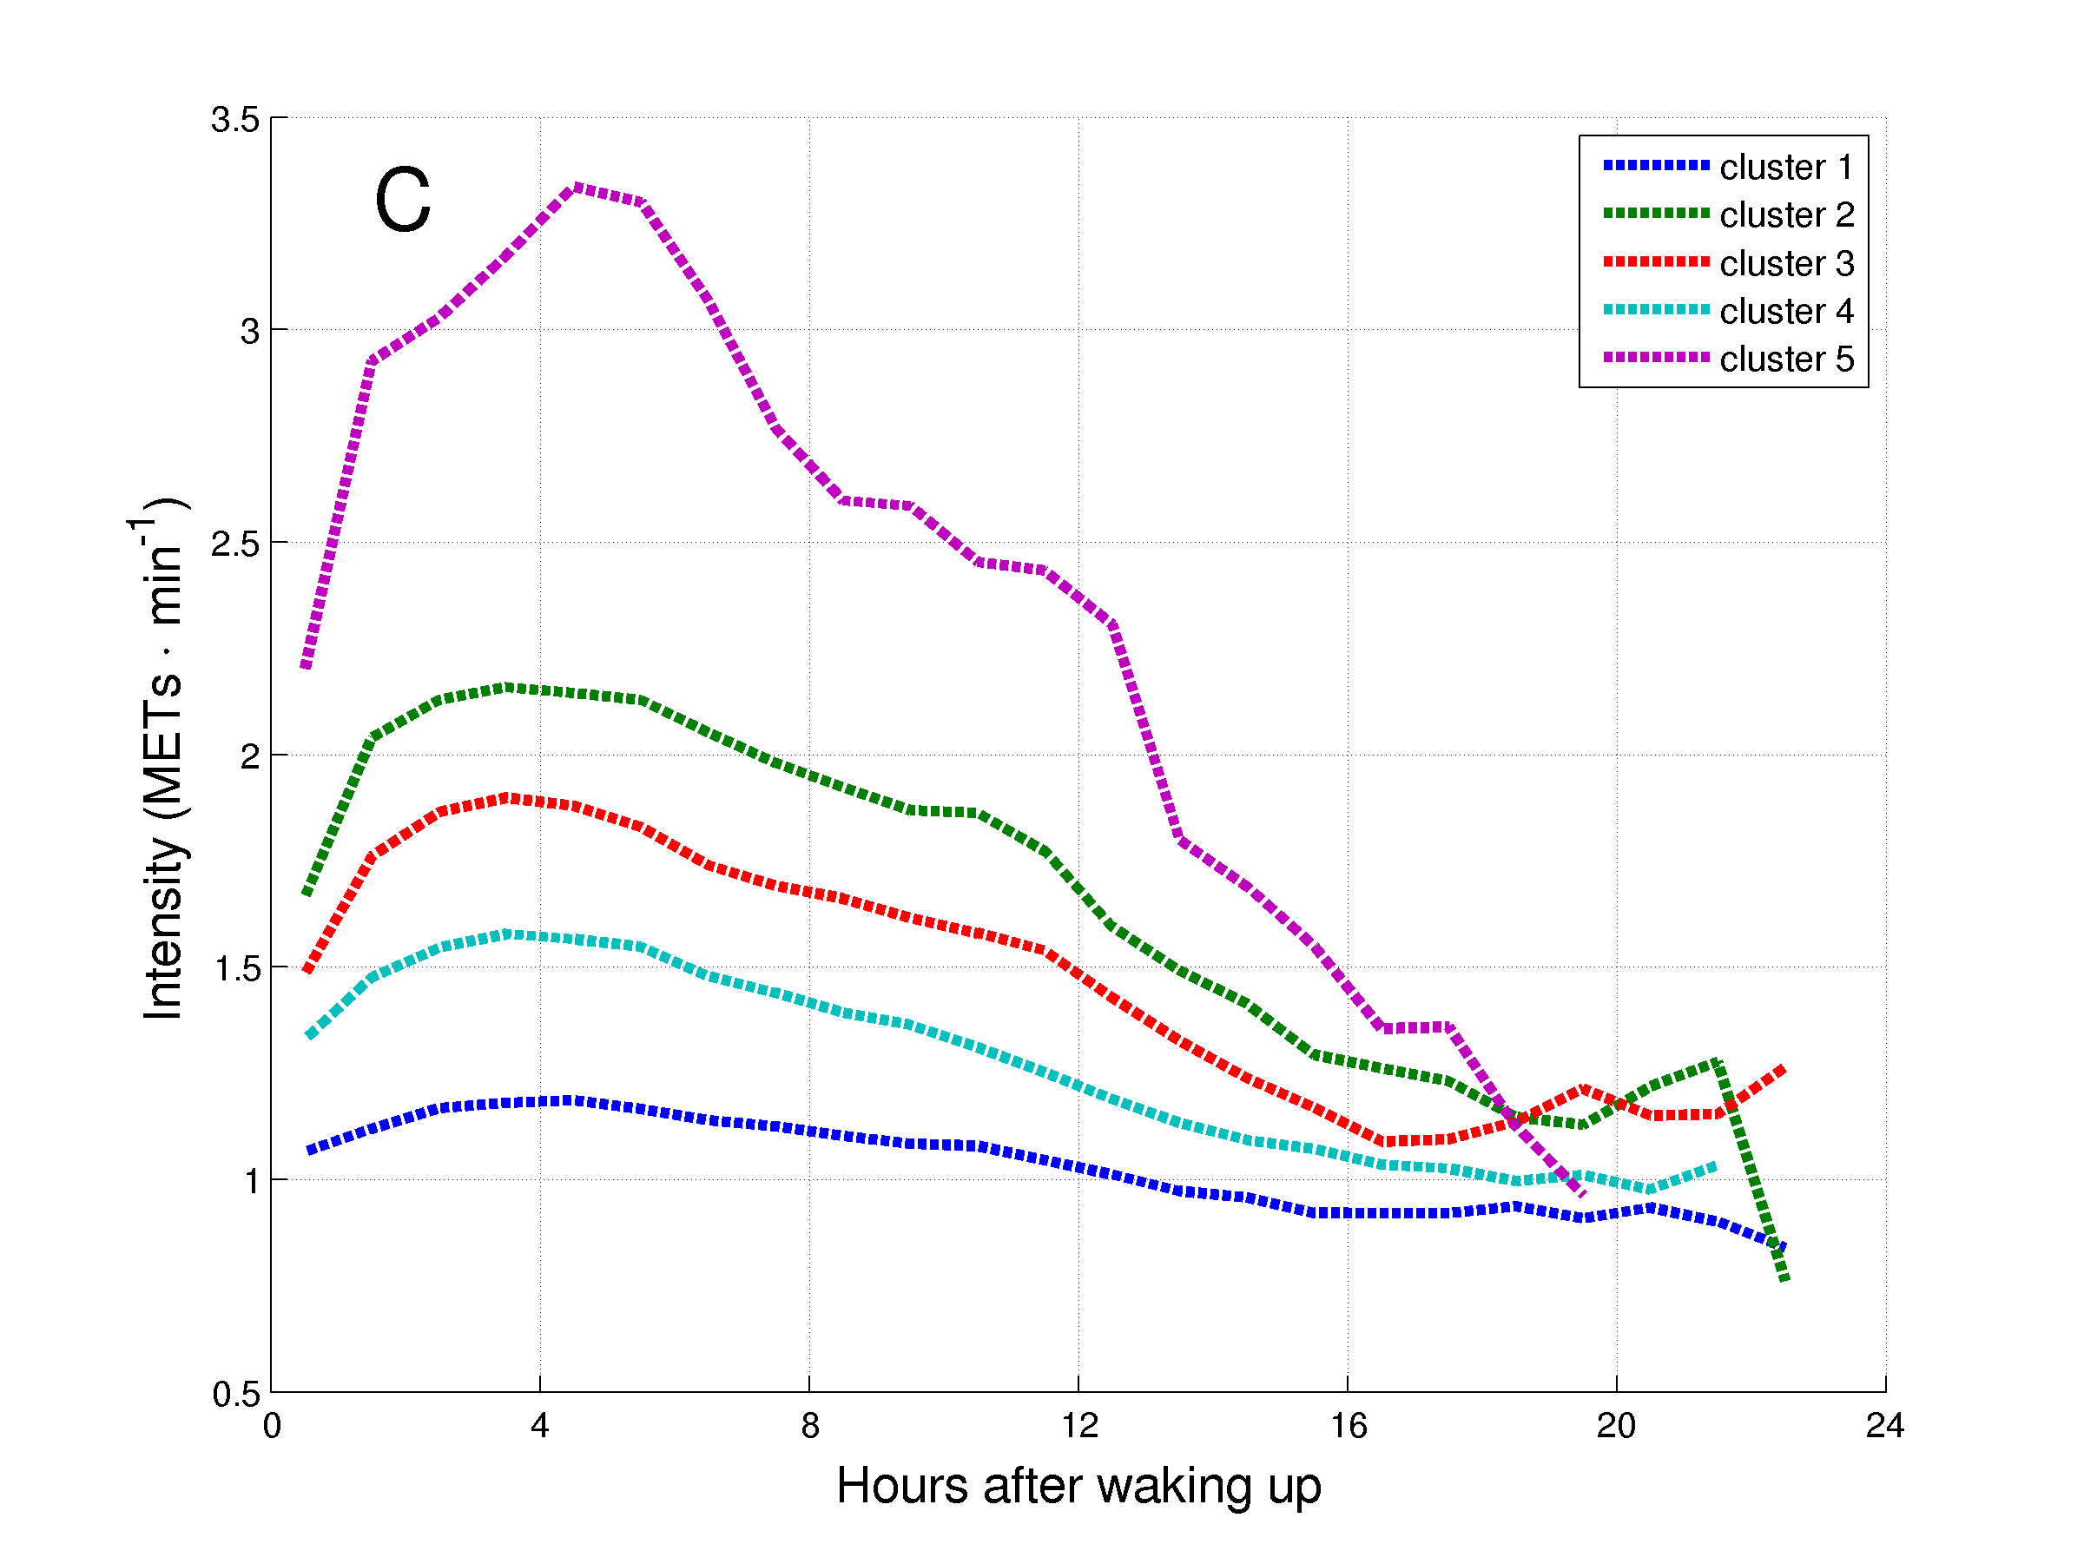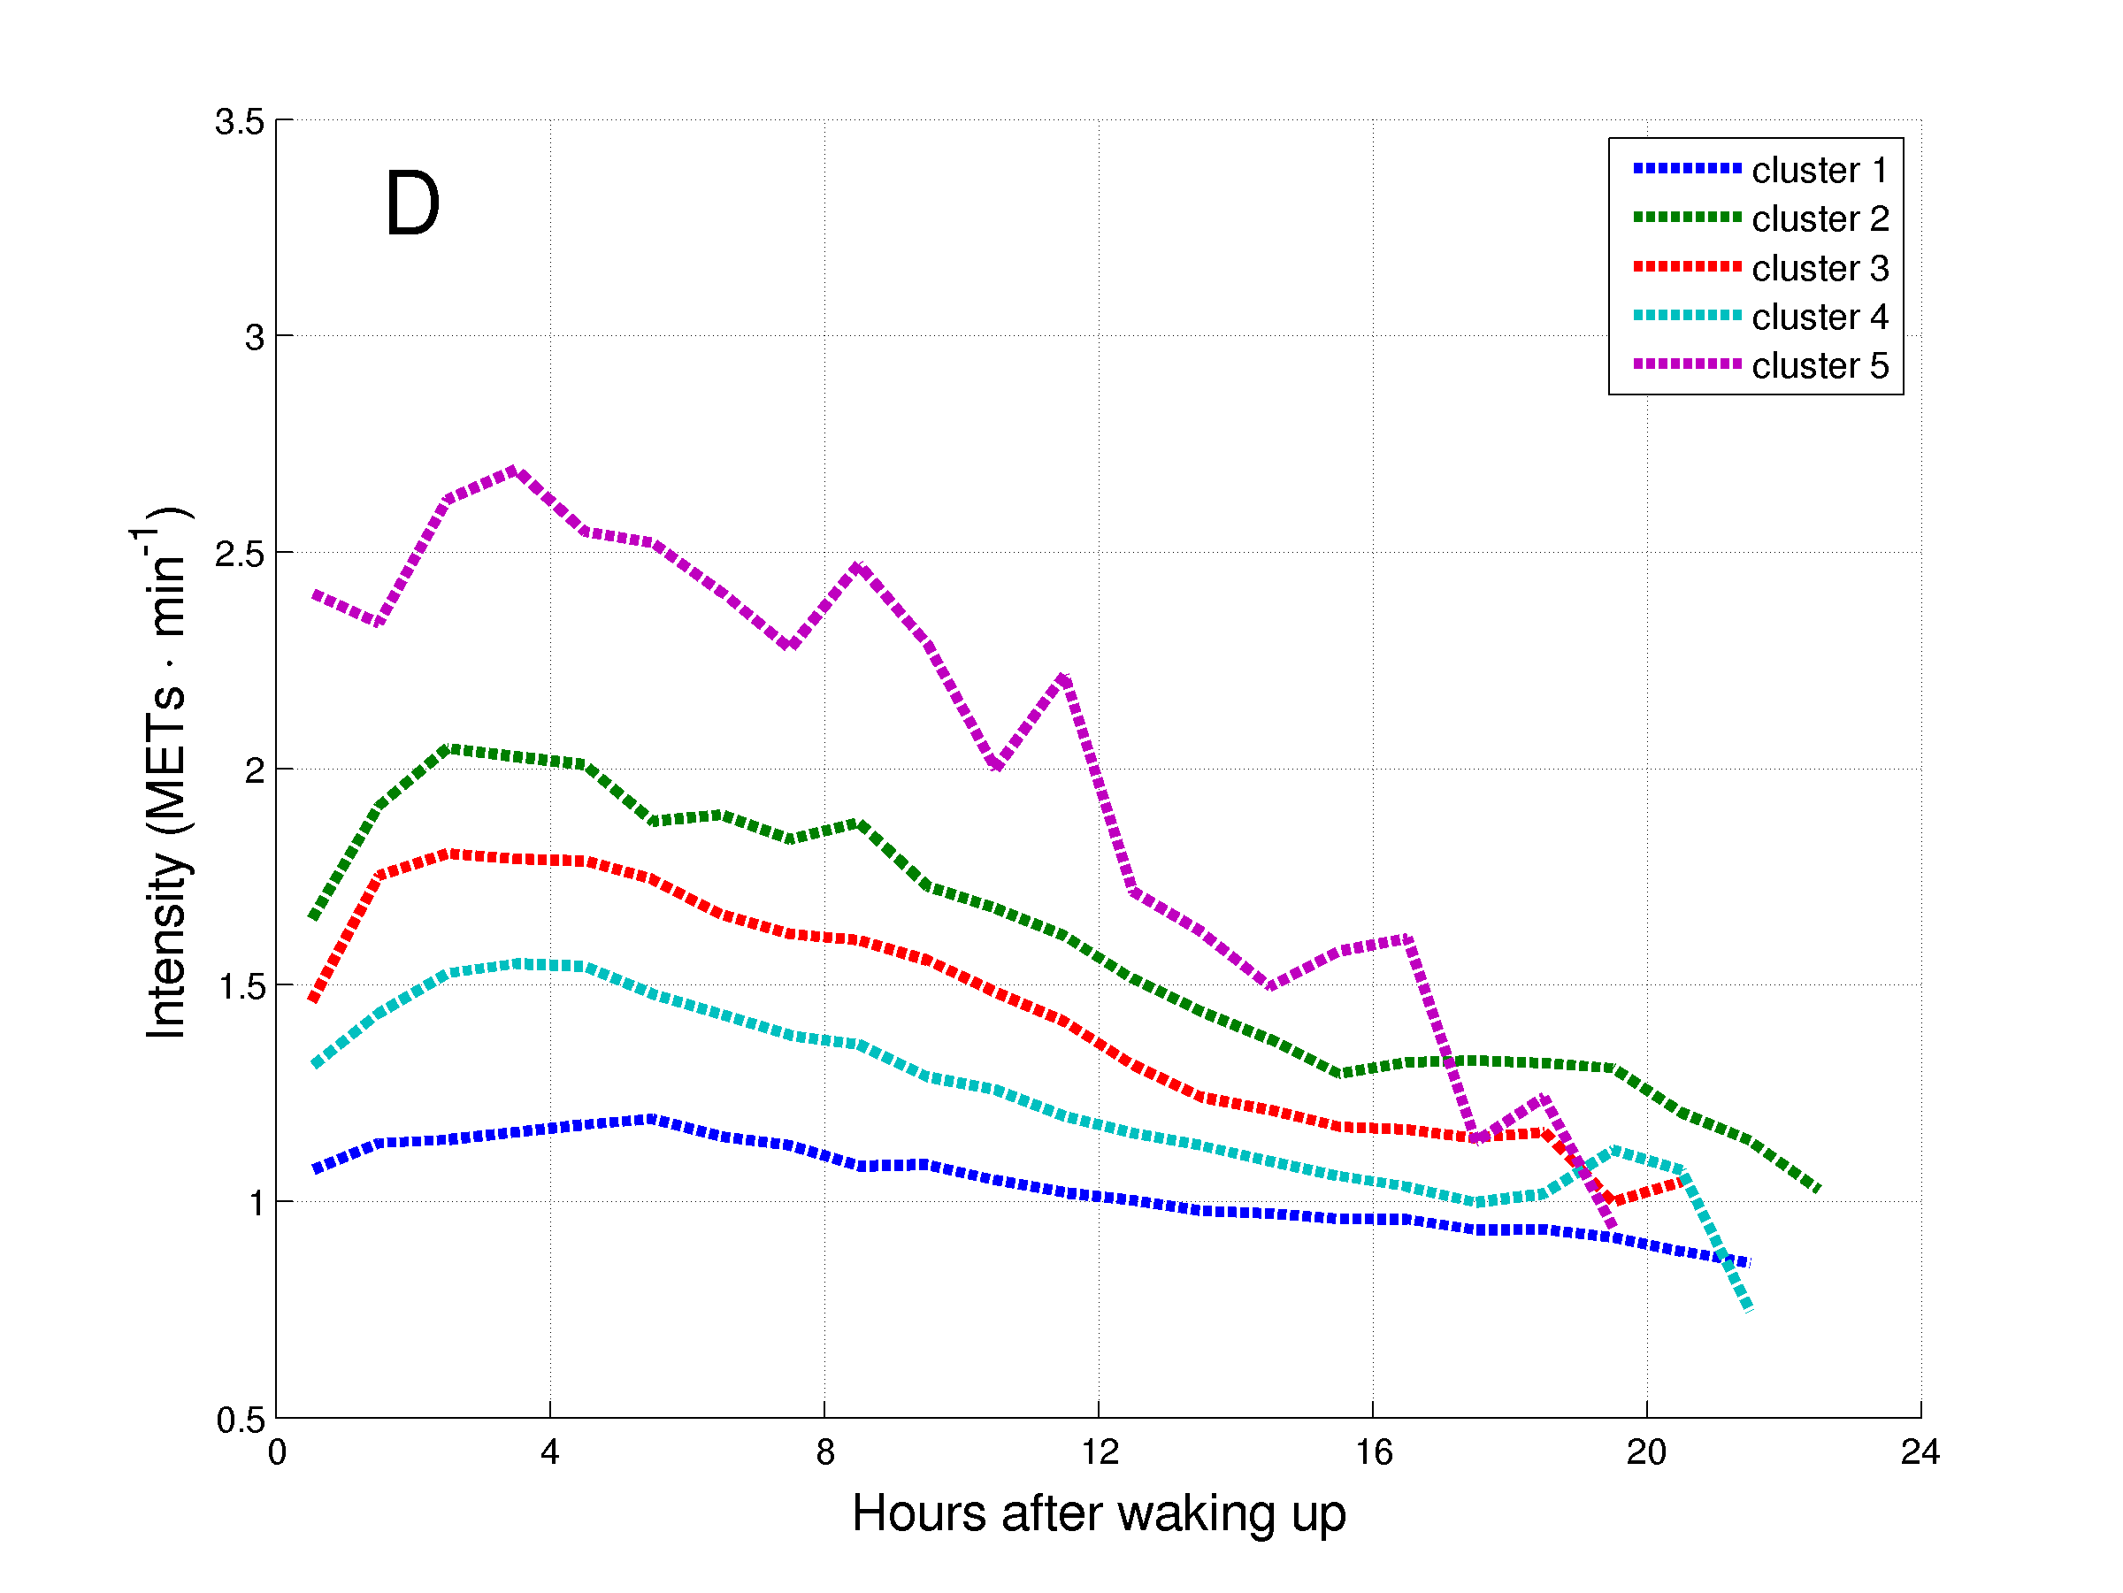

***Figure 6.*** Daily hourly pattern of the clusters of patients with COPD during weekdays (A and C) and weekend days (B and D), and before (A and B) and after (C and D) synchronization of the waking up moment.